eSign Product Specification & UXD (v2)
Date: Sept 9, 2025
Owner: Product / UX
Audience: Engineering, Design, Compliance, IT, Sales/CS

1) Executive Summary
Build a secure, enterprise-grade electronic signature product that streamlines preparation, signing, and archival of documents, with native Microsoft 365 integration. The experience emphasizes speed-to-sign, compliance-grade auditability, and a frictionless mobile/desktop signer journey. The final signed document and certificate are delivered by email to all parties, with optional auto-archive to SharePoint/OneDrive.
Primary outcomes - Increase completion rate to ≥ 95% within 72 hours. - Reduce sender prep time to ≤ 3 minutes for templated documents. - Achieve legally robust evidence (tamper-evident audit trail + certificate of completion).

2) Business Goals & KPIs
- Time to sign (median, p95 by flow)
- Completion rate and drop-off by step
- Template utilization (ratio of templated vs ad‑hoc sends)
- Error rate (bounces, invalid emails, mismatched fields)
- MS 365 adoption (Outlook/SharePoint/Teams usage)
- SLA: Email delivery < 60s; webhooks < 10s; search index < 2m

3) Personas
- Sender (Ops/CS/HR/Legal/Finance): Prepares packages, sets roles/order, tracks status. Wants speed, zero rework.
- Signer (External/Internal): Signs without creating an account, on any device, in EN/AR, low friction.
- Approver/Reviewer: Optional non-signing reviewer, parallel or serial routing.
- Admin (IT/Compliance): Governs templates, retention, SSO, policies.
- Security/Compliance Officer: Needs audit trails, hashing, immutable storage, exports.
- Developer (Integrator): Wants clean APIs/webhooks, sandbox, examples.

4) In Scope
- Document prep, roles, routing (serial/parallel/hybrid).
- Field controls (signature, initials, text, date, checkbox, stamp, company seal).
- Authentication (email OTP, SMS OTP, AD SSO for internal users).
- Reminders/expiry, send-backs with change-scoped rework.
- Audit trail + Certificate of Completion (PDF).
- Microsoft 365 integration (Outlook add‑in, SharePoint/OneDrive, Teams).
- Notifications: email + Teams; final delivery by email.
- API + webhooks (event-driven).
- Localization: EN/AR, full RTL support; WCAG AA.
- Storage: platform vault + optional SharePoint/OneDrive auto-archive.
Out of scope (v2 will revisit): Qualified/eID signatures, notary, advanced KSA NID-provider eKYC, advanced form logic.

5) User Journeys

5.1 Sender: Prepare & Send
- Start: New → upload doc (PDF/DOCX) or choose template.
- Recipients & Roles: Add signer(s), approver(s); define order (serial/parallel); set auth method per role.
- Place Fields: Drag fields; lock formatting; add validations (e.g., IBAN mask).
- Review & Checklist: Preflight checks (missing fields, overlaps, unassigned fields).
- Send: Confirmation with summary; optional internal note and metadata tags.
- Track: Real-time timeline, SLA badges, reminder scheduling, send-back management.
- Complete: Final signed PDF + certificate auto-emailed to all parties; archived to SharePoint folder if configured.
Best practices embedded
- Guided steps with progress (1–5), autosave drafts, preflight error panel.
- Parallel routing where possible; send-back targets only the failing lane (others continue to the join).
- Clear microcopy and guardrails (e.g., “You’re about to request 3 signatures in parallel”).

5.2 Signer: Frictionless Signing
- Open Link: Deep link from email/Teams; no login required.
- Authenticate: OTP (email/SMS) depending on policy.
- Review & Consent: Legal consent banner (ESIGN/UETA/eIDAS; local regulations).
- Sign: Click-to-sign/draw/upload-stamp; guided “Next field” focus on mobile.
- Finish: Confirmation, download; final signed copy and certificate via email.
- Accessibility: Keyboard nav, screen reader labels, high contrast; RTL UI for Arabic.

5.3 Approver/Reviewer
- Inline comments; approve/return with reason. Send-back only reopens impacted section(s).
- SLA timer independent per lane with escalation to owner.

5.4 Admin / IT
- Manage templates, roles, policies (auth strength, expiries).
- Configure M365: SharePoint library mapping, Outlook add‑in deployment, Teams notifications.
- Data retention & legal hold; export logs & certificates.

6) Functional Requirements

6.1 Document Prep & Fields
- Upload: PDF/DOCX; auto-convert to signing canvas.
- Field types: Signature, Initials, Text (masks), Date, Checkbox, Radio, Dropdown, Company Seal/Stamp, Attachment.
- Validation: regex, required, length; per-field tooltip and error.
- Templating: Named roles, predefined fields, locked content, versioning; merge tokens {{FirstName}}, etc.
- Bulk Send: CSV mapping for 1→N sends.
- Prefill: From URL params or API payload.

6.2 Routing & Roles
- Modes: Serial, Parallel, Hybrid (fork–join).
- Send-back: Change-scoped rework; only failing lane reopens; freeze at join until all lanes pass.
- Delegation: Allow signer to reassign (policy-controlled).
- Reminders & Expiry: Schedule cadence (daily/2‑day/weekly); hard expiry with revoke.

6.3 Authentication & Security
- Email OTP (default), SMS OTP; AD SSO for internal users; IP allow/deny list (admin).
- Doc integrity: Hash on upload; post-sign hash stored; tamper-evident PDF.
- Certificate of Completion: timestamps, signer auth method, IP, device, event log.
- Encryption: Data in transit (TLS 1.2+), at rest (AES‑256), per-tenant keys optional.
- Audit: Immutable log store; exportable CSV/JSON; SIEM integration.

6.4 Notifications & Delivery
- Transactional emails: invite, reminder, completed; multi-language.
- Teams notifications (personal scope app or adaptive cards).
- Final step: Email delivery of signed PDF + certificate to all parties; optional SharePoint auto-archive to mapped library.
- Webhooks: package.sent, package.viewed, package.signed, package.completed, package.expired, package.declined.

6.5 Microsoft 365 Integrations
- Outlook add‑in (Office.js): “Send for signature” from compose; attaches selected file(s); opens recipient/role picker; tracks status within add‑in.
- SharePoint/OneDrive: Library picker; store originals and completed docs; preserve metadata (Content Type, columns).
- Teams: Adaptive Card notifications; /esign status {packageId} command; deep link to track page.
- AD: SSO (OIDC/SAML), SCIM for user provisioning; Conditional Access support.
- Graph API (later): Auto-file to user’s OneDrive/Shared Library via app consent.

6.6 API & Extensibility
- REST + Webhooks; SDKs (JS/TS, Python).
- Sandbox with API keys; Postman collection; sample apps.
- Rate limits (documented); idempotency keys for sends.
- Template APIs: create, version, publish, lock; bulk send endpoint.

6.7 Storage, Retention, eDiscovery
- Default vault storage (region-selectable); optional SharePoint/OneDrive as primary or secondary archive.
- Retention policies: per-doc/per-template; legal hold.
- Global search with filters (status, signer, tag, date, library).

6.8 Localization & Accessibility
- Full Arabic RTL UI; bilingual emails; Gregorian/Hijri dates toggle (settings).
- WCAG 2.1 AA; keyboard focus order; labels and alt text; error text paired with fields.

7) Non‑Functional Requirements (NFRs)
- Availability: 99.9% monthly; multi‑AZ deployment.
- Performance: First view < 2s p50, < 5s p95 on 4G; field drag latency < 50ms.
- Scalability: 100k concurrent signer sessions; burst queue for invite sends.
- Reliability: Exactly-once webhooks; retry with exponential backoff; dead-letter queue.
- Privacy/Compliance: ESIGN/UETA, eIDAS (basic), GDPR controls (export/delete); local regulatory alignment (legal review gate).
- Security: OWASP ASVS L2; quarterly pen‑tests; SAST/DAST in CI; CSP headers.

8) UXD: Information Architecture & Screen Specs

8.1 IA (Top-level)
- Dashboard (My packages, Awaiting me, Templates, Reports)
- New Package (Upload/Template → Recipients → Fields → Review → Send)
- Templates (create, version, publish, permissions)
- Admin (Policies, Integrations, Retention, Users/Roles)
- Reports (funnels, SLA, completion, MS365 adoption)

8.2 Screen-by-Screen (Key Elements & Acceptance Criteria)
Dashboard
- Cards: In Progress, Awaiting Others, Awaiting Me, Completed.
- Filters: owner, tag, status, date.
- AC: Loads in <2s; infinite scroll; bulk reminder; export CSV.
New → Upload/Template
- Drag-drop or pick from SharePoint.
- AC: File types PDF/DOCX; virus scan pass; immediate preview.
Recipients & Roles
- Table: Name, Email, Role (Signer/Approver/CC), Auth, Order.
- AC: Prevent duplicate emails; validate domains; set parallel groups; OTP policy mapping.
Fields Canvas
- Sidebar: Field palette; Properties; Alignment tools.
- AC: Snap-to-grid; collision detection; required indicators; role bindings.
Review & Send
- Checklist: Unassigned fields, missing auth, missing subject/body.
- AC: Block send if critical errors; show estimated completion time; confirm.
Track Package
- Timeline with events; SLA badge per recipient; send-back controls.
- AC: Real-time updates via websockets; reminder schedule; revoke/expire.
Signing UI
- Steps: Consent → Auth → Guided fields → Review → Finish.
- AC: Mobile-first; “Next field” focus; save & resume; downloadable final PDF + certificate.
Admin → Integrations (MS 365)
- Tabs: Outlook add‑in deployment, SharePoint mapping, Teams notifications.
- AC: Validate Graph scopes; test connection; choose libraries/folders; set default archive path per template.

9) Best-Practice Elements (Design & Process)
- Progressive disclosure: Only show advanced options when needed.
- Preflight checks: Zero critical errors before send; fix‑it links.
- Autosave drafts; undo/redo in canvas.
- Parallel review + change-scoped rework: Keep other lanes moving; freeze at join.
- Microcopy: Clear, task‑oriented labels; error messages that state the fix.
- Empty states with sample templates; skeleton loaders for perceived performance.
- One‑tap reminders; sane defaults (24h then every 2 days).
- Accessible patterns: Min 44px targets; contrast ≥ 4.5:1; ARIA roles; focus visible.
- Security nudges: Warn on weak auth for high‑risk templates; suggest SMS OTP/SSO.
- Template governance: Owner + reviewers; lock critical fields; versioning & publish flow.
- Internationalization: EN/AR parity; RTL QA checklist; date/number localization.
- Observability: User journey analytics + error budgets; session replay for support (redact sensitive).

10) Analytics & Telemetry
Events: upload_started, fields_completed, send_clicked, invite_delivered, viewed, otp_passed, signed, completed, send_back, reminder_sent, archived_m365.
Funnels: Sender prep, Signer completion; MS 365 adoption.
Dashboards: Time-to-sign, completion, drop‑offs by step, SLA breaches; top templates.

11) Release Plan
- v1: Core prep/sign/complete; email delivery; SharePoint auto-archive; Outlook add‑in (basic); Teams notifications (basic).
- v1.1: Bulk send; CSV merge; Graph file‑to‑library; webhook retries UI.
- v1.2: Advanced policies; SCIM; analytics dashboards; admin reports.

12) Risks & Mitigations
- Email deliverability → SPF/DKIM/DMARC, dedicated IPs, feedback loops.
- Regulatory variance → Configurable policies; exportable evidence; legal review gate.
- M365 tenant diversity → Tenant-by-tenant app consent; fallback to manual file download.

13) Open Questions
- Required data residency/sovereignty constraints?
- Preferred SMS provider(s) and KSA routing compliance?
- Certificate branding: co-brand vs platform-only?
- Exact SharePoint library structure and metadata columns per template?
- Any mandatory national eID integrations for later phases?

APPENDIX
Wireframes

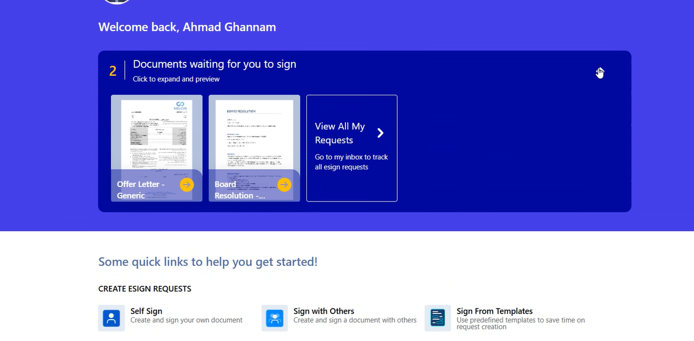
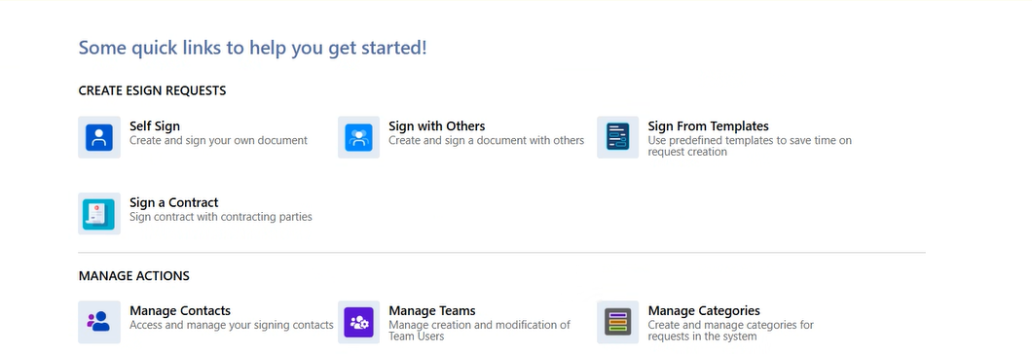
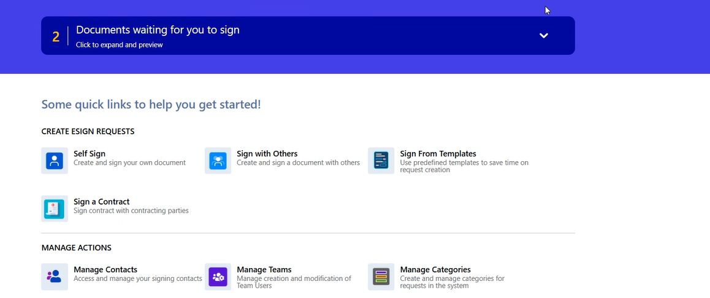
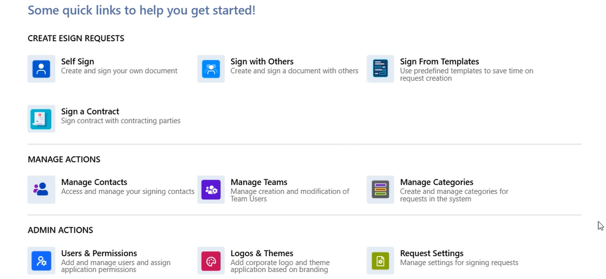
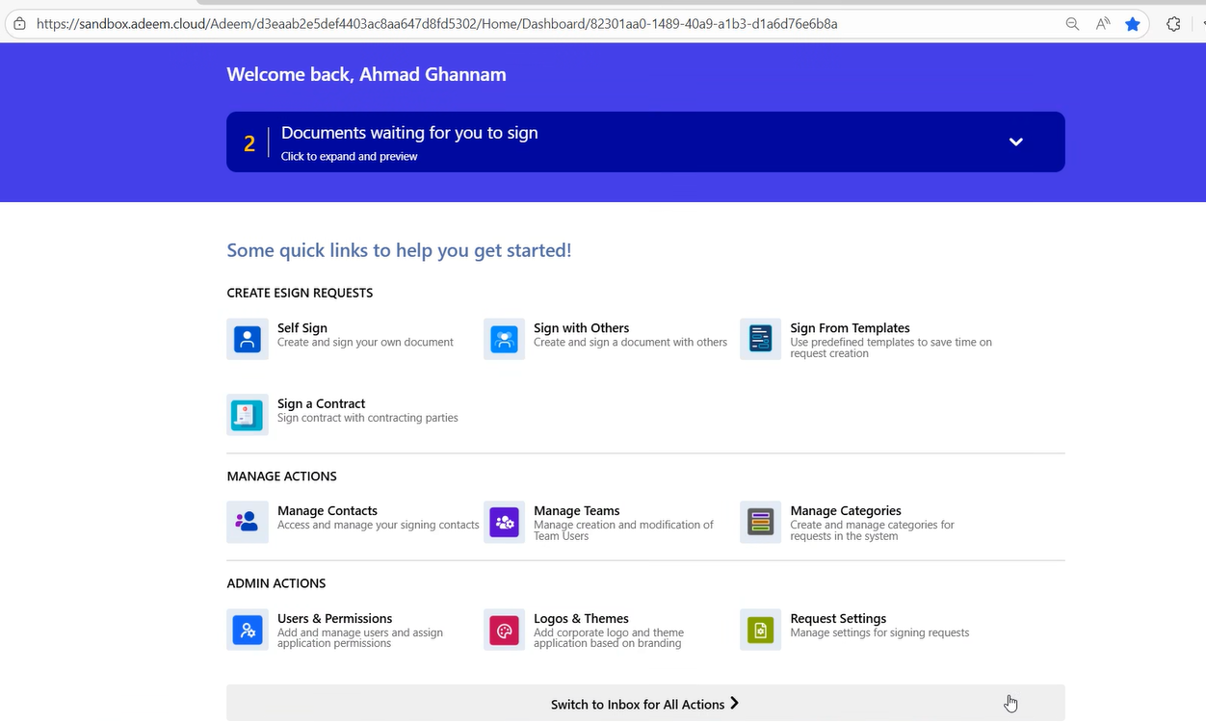
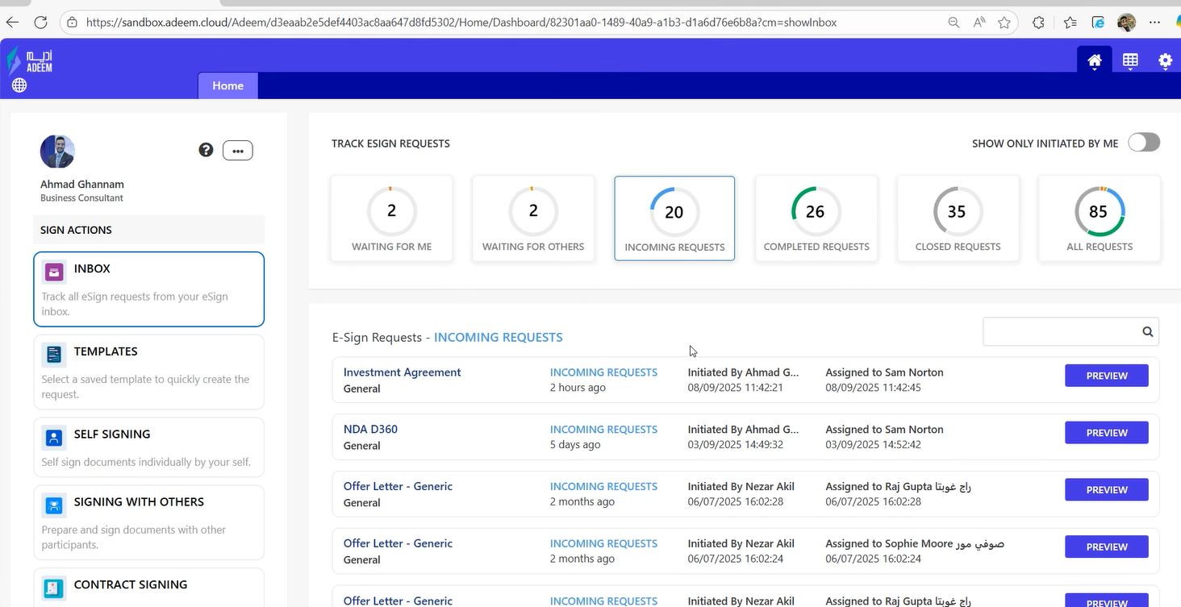
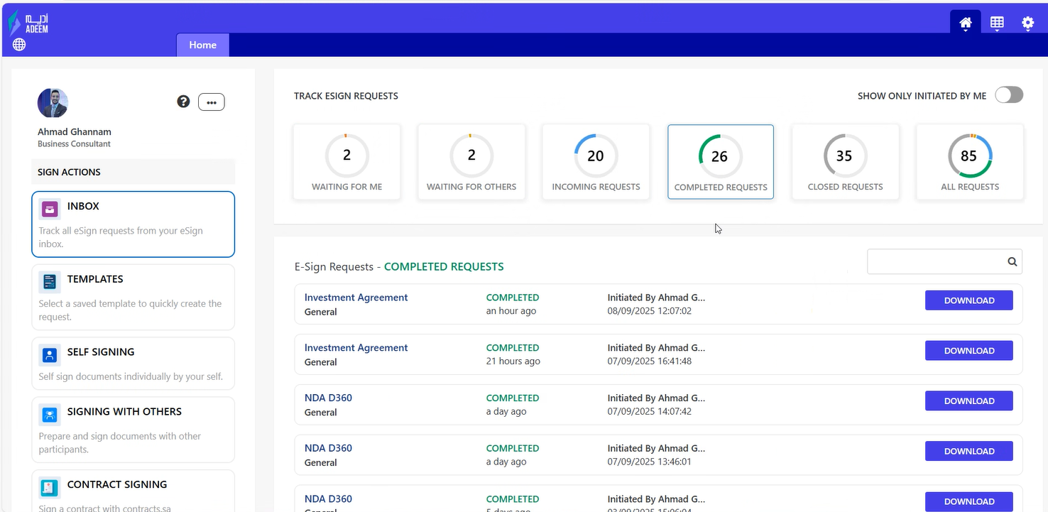
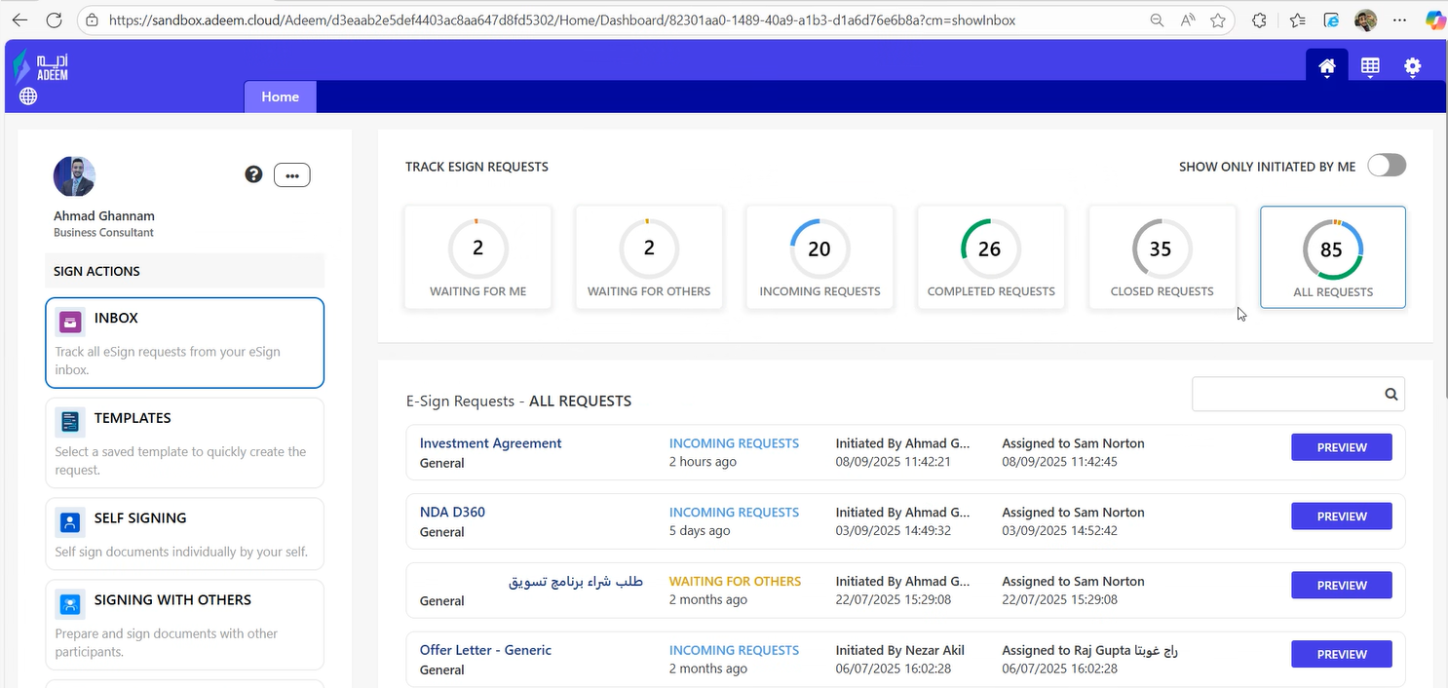
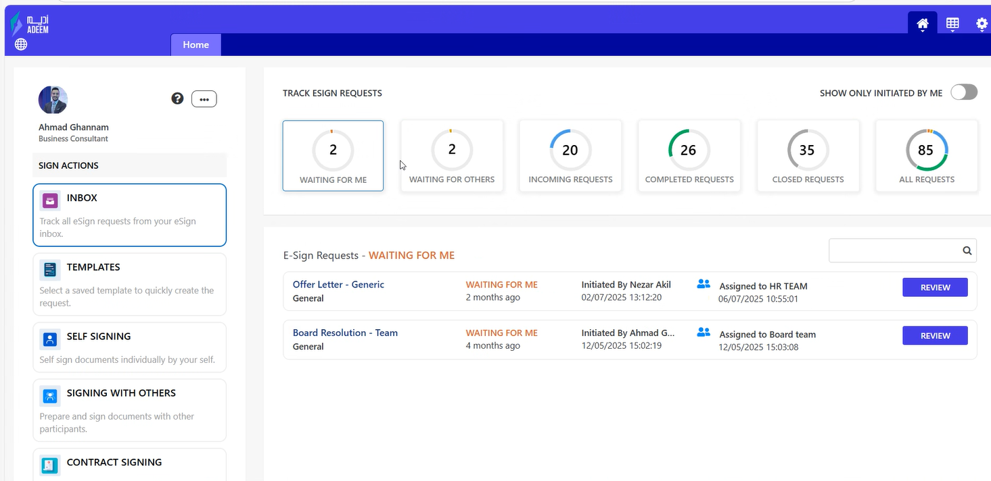
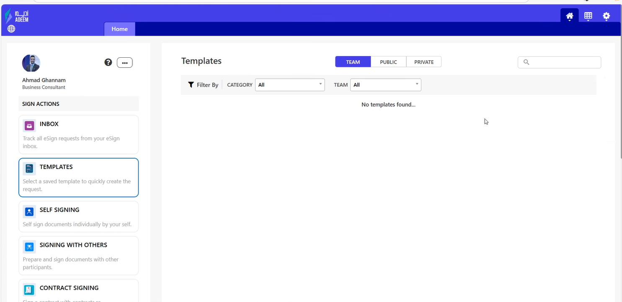

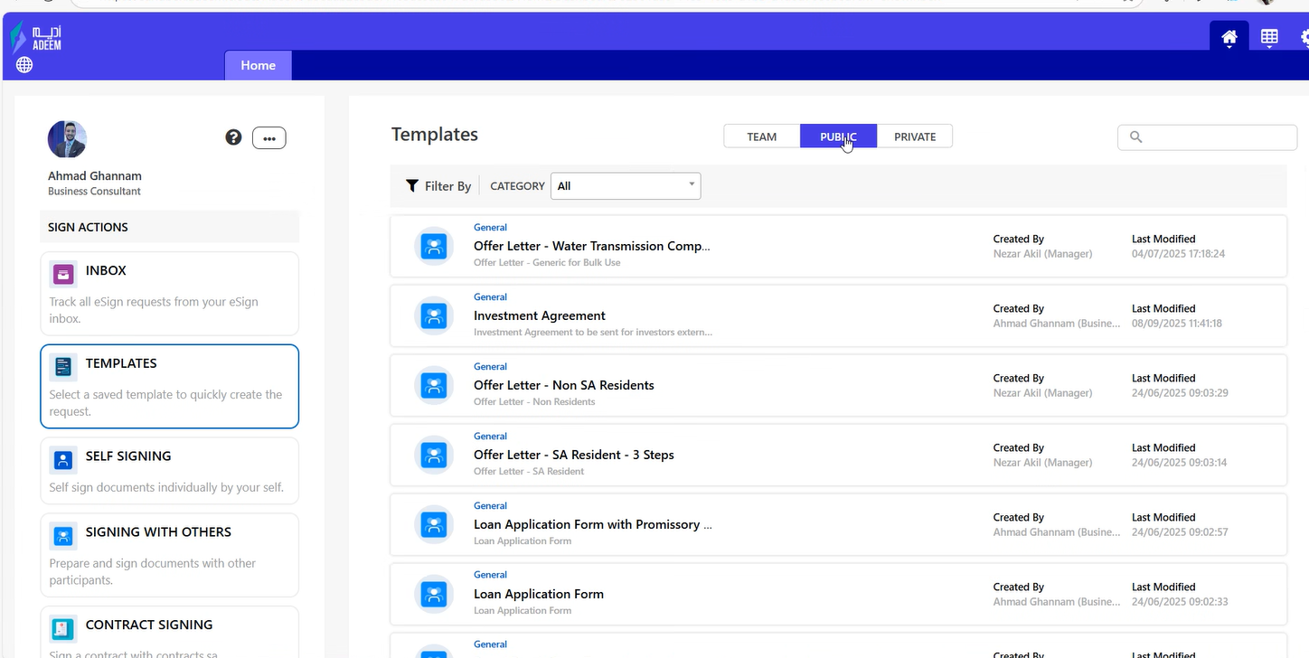
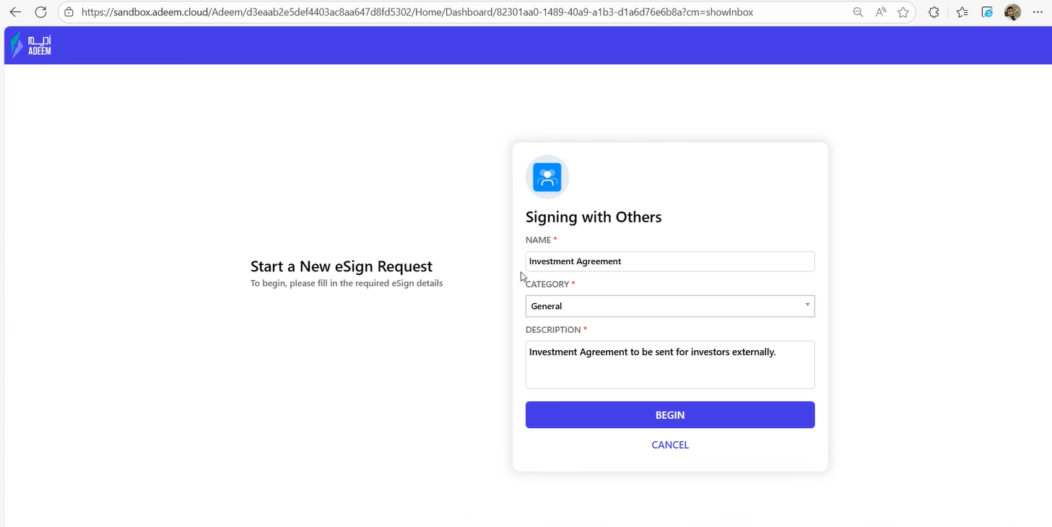
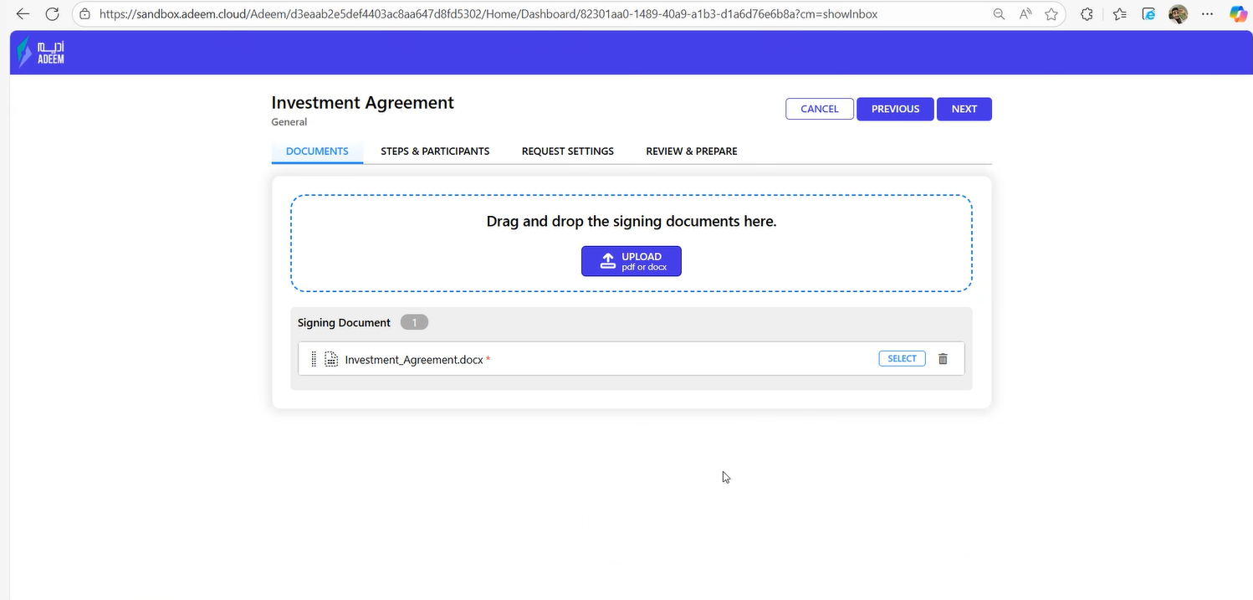
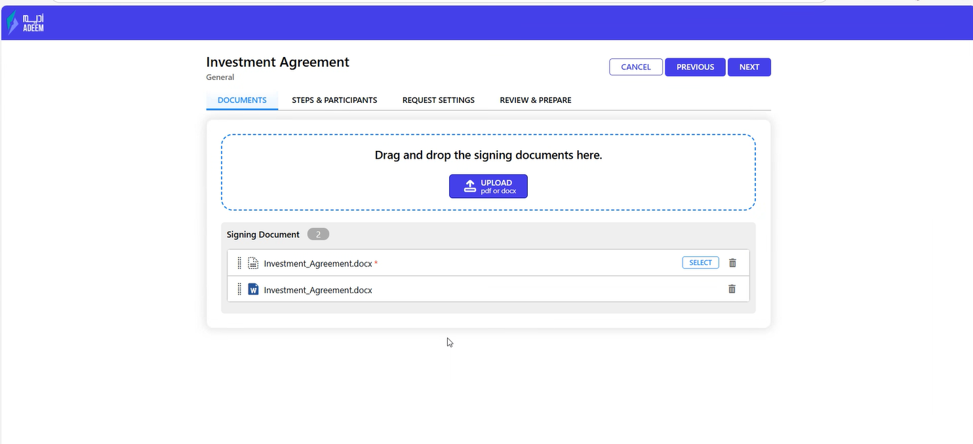
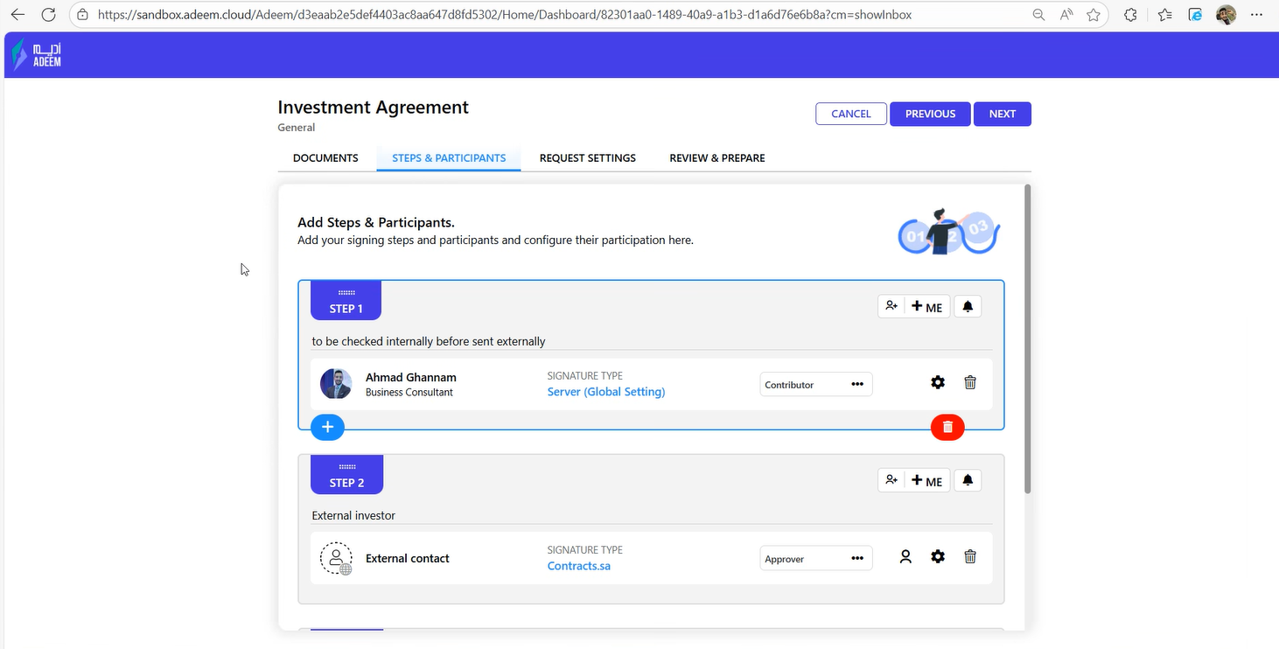
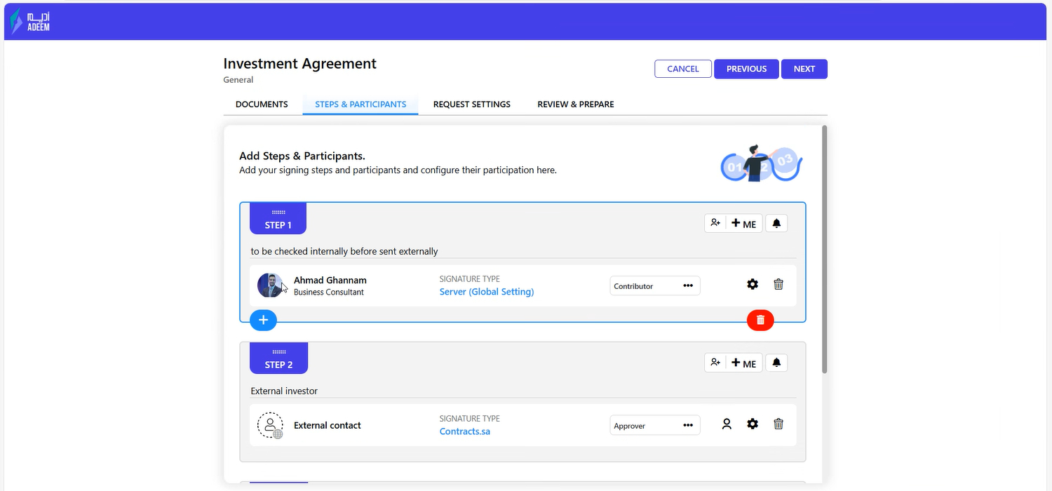
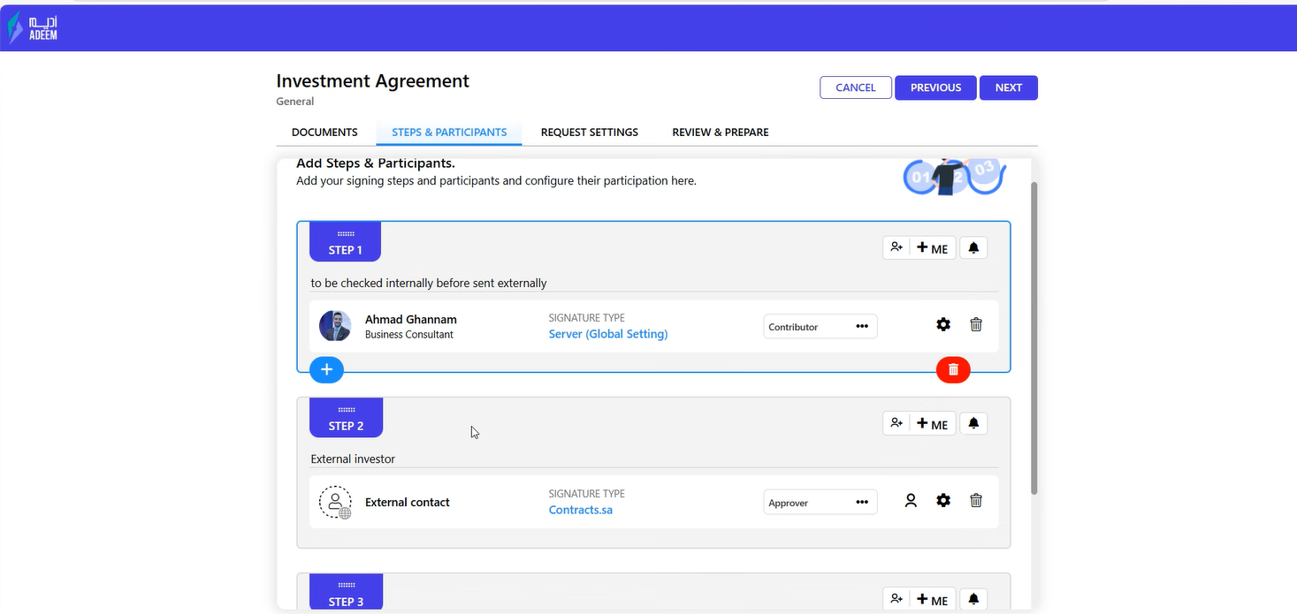
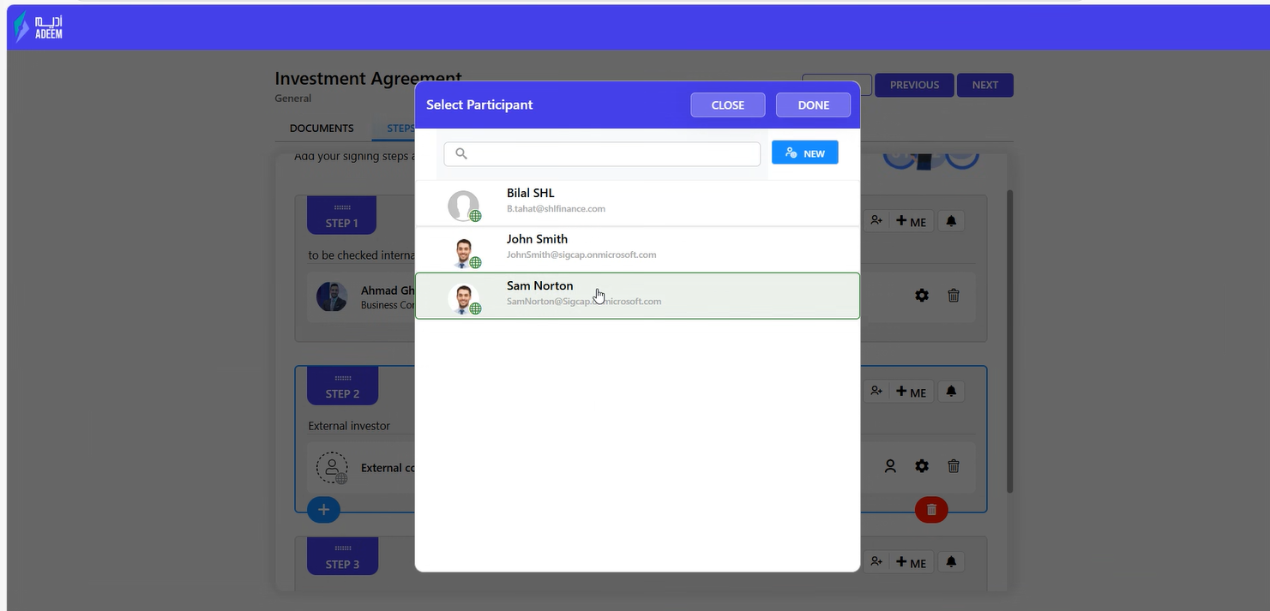
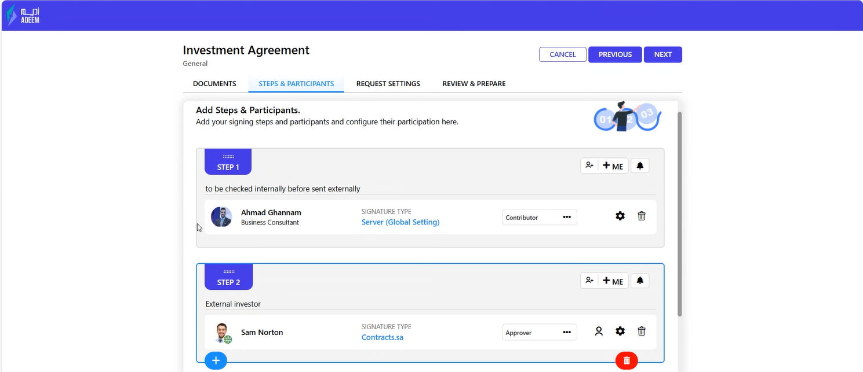
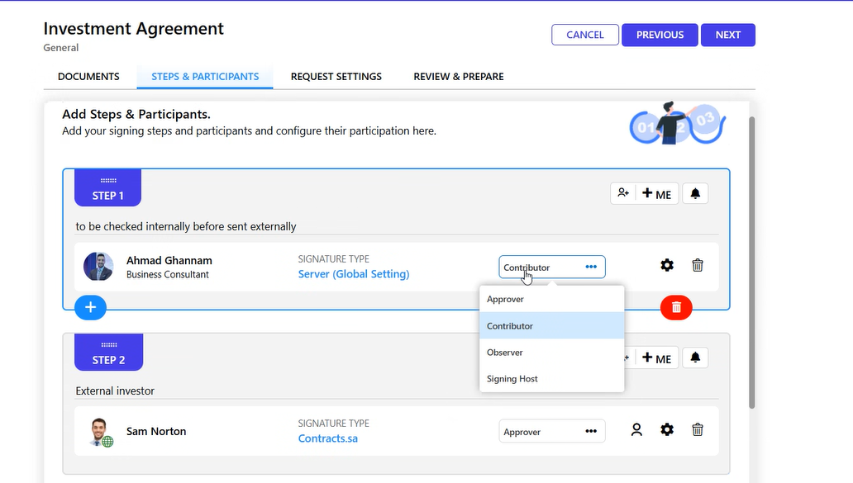
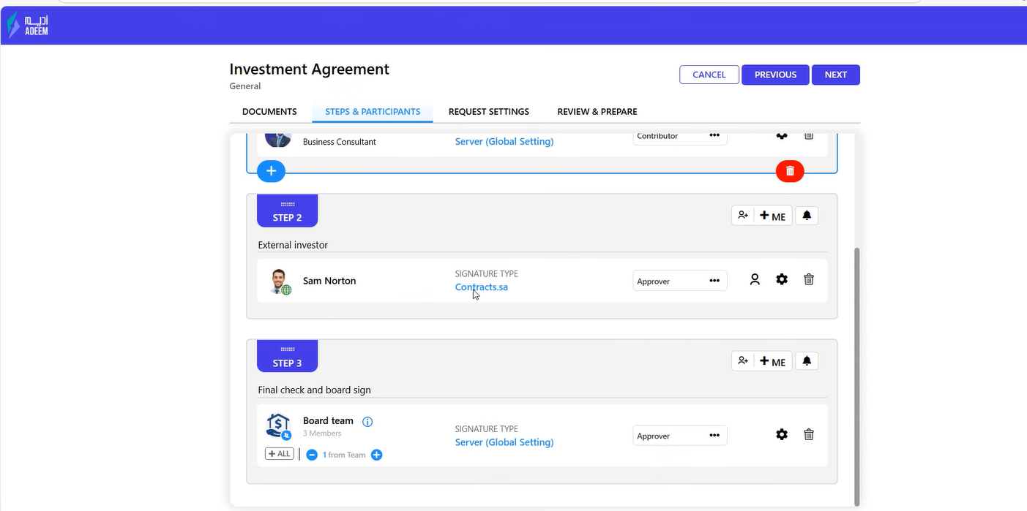
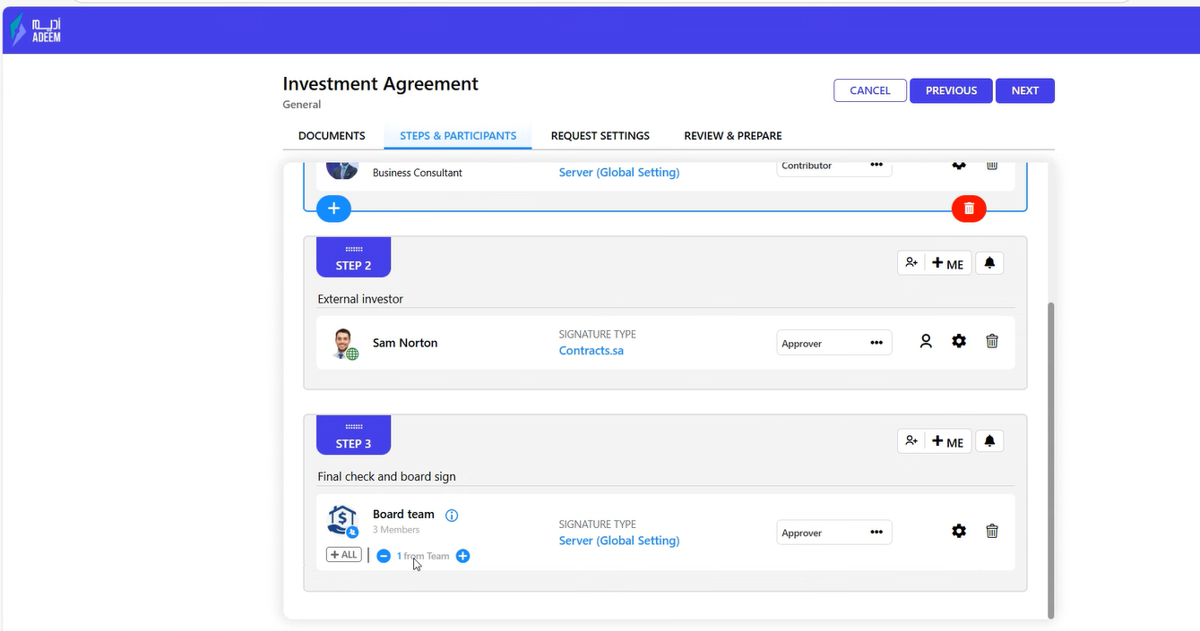
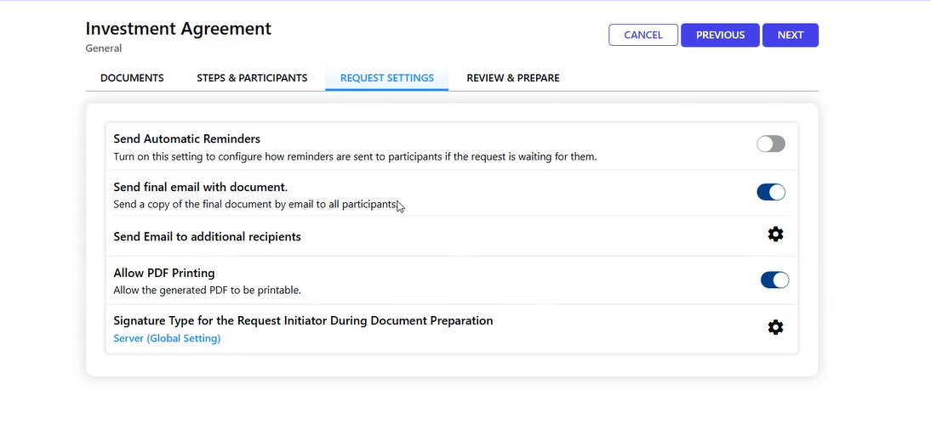
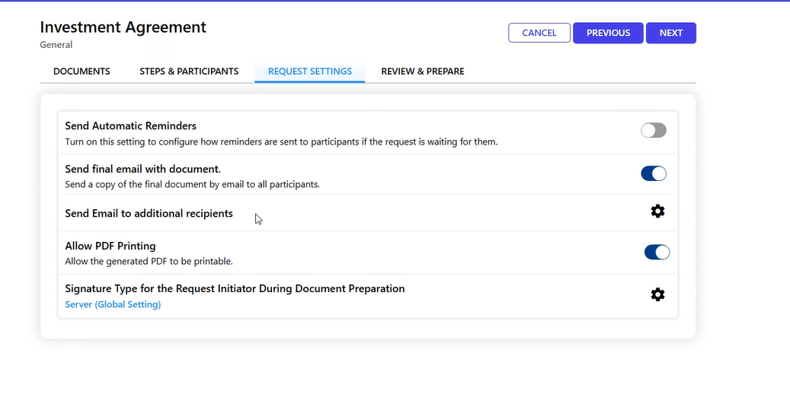
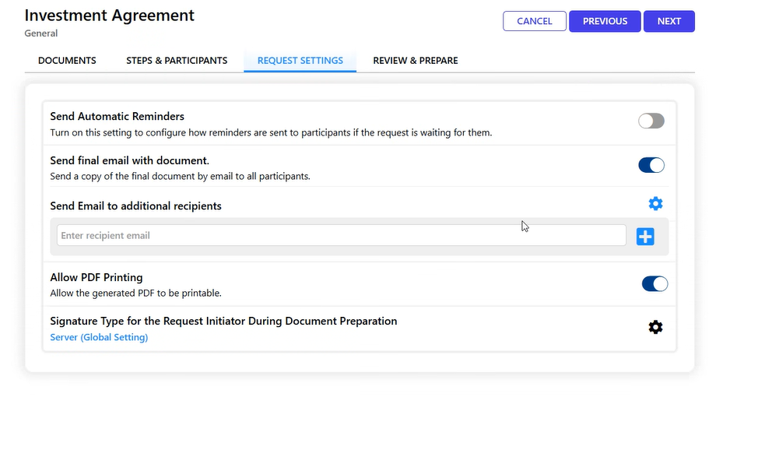
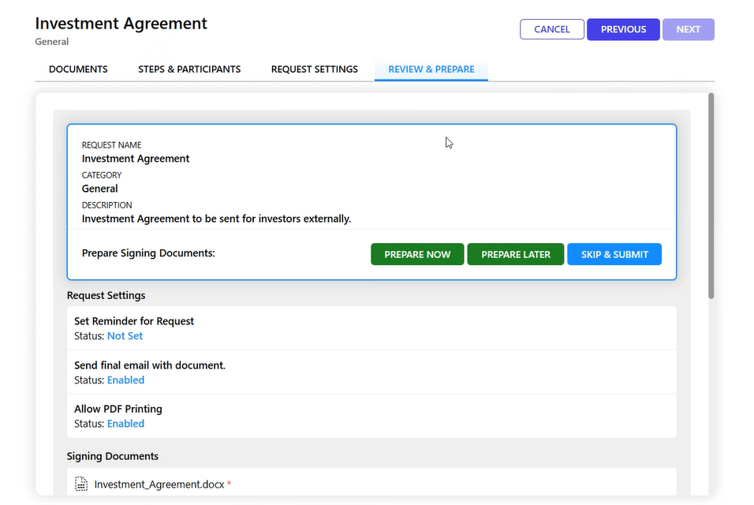
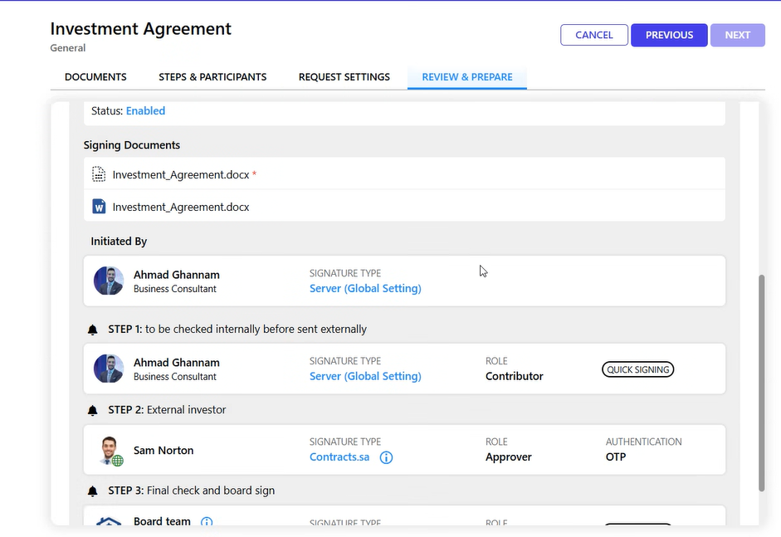
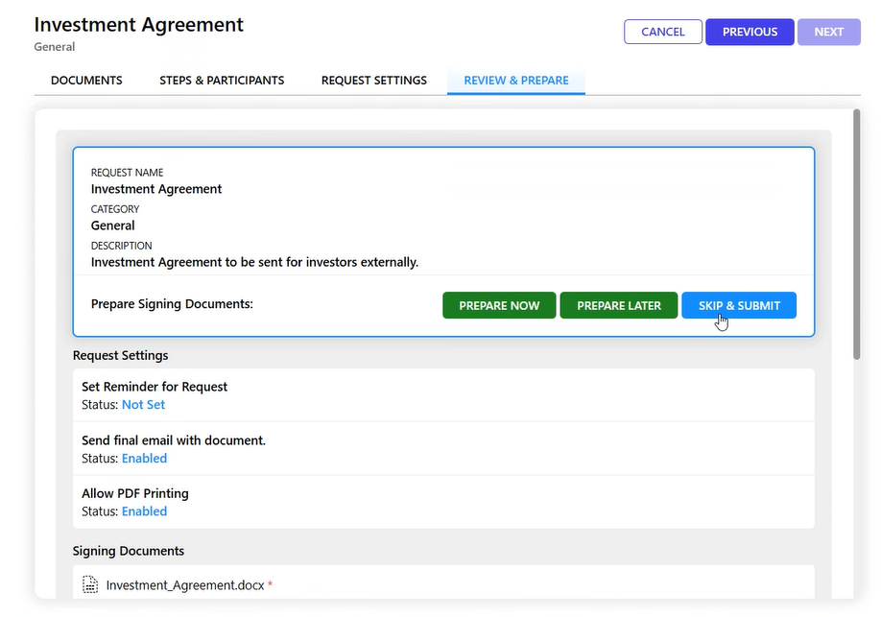
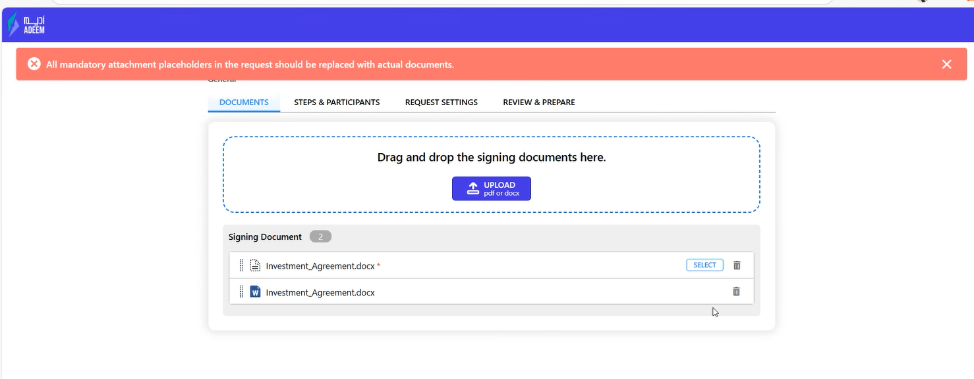
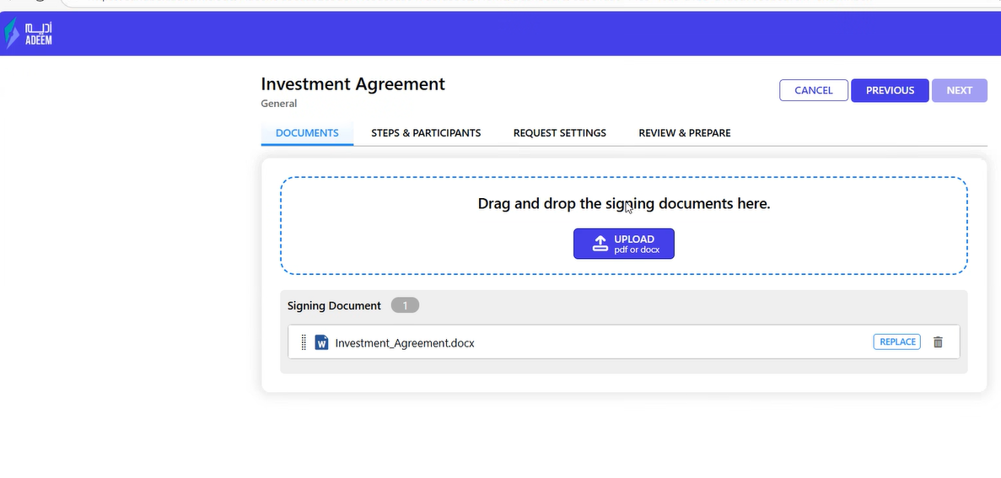
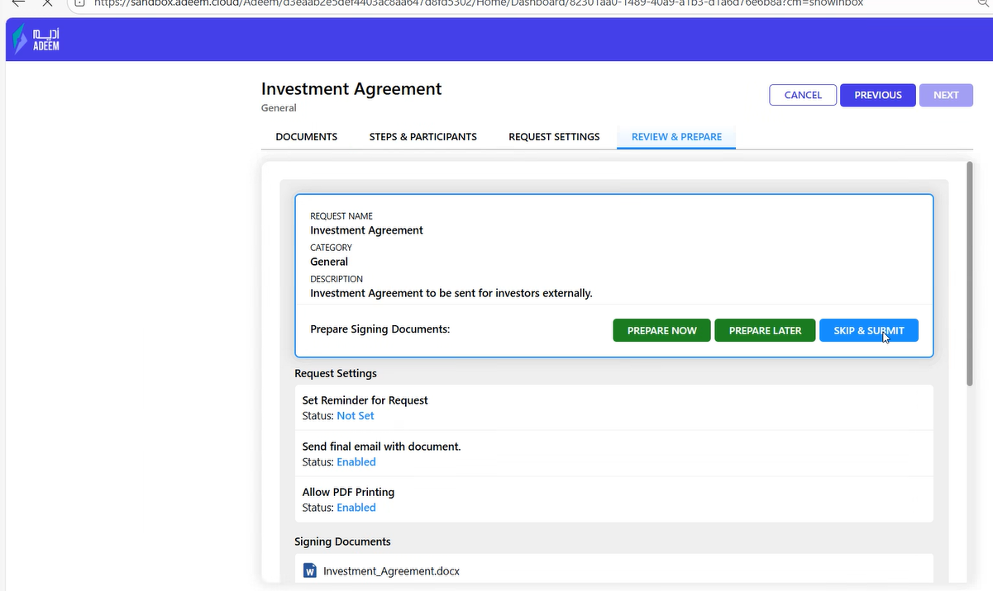
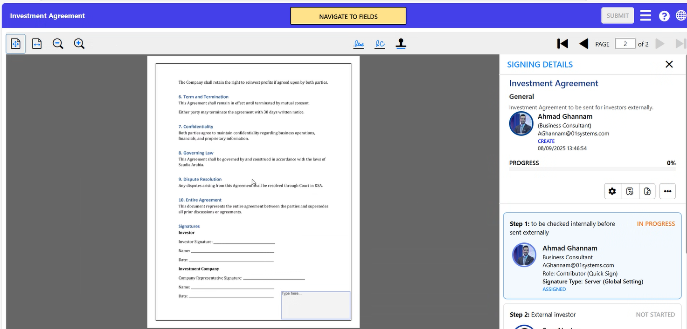

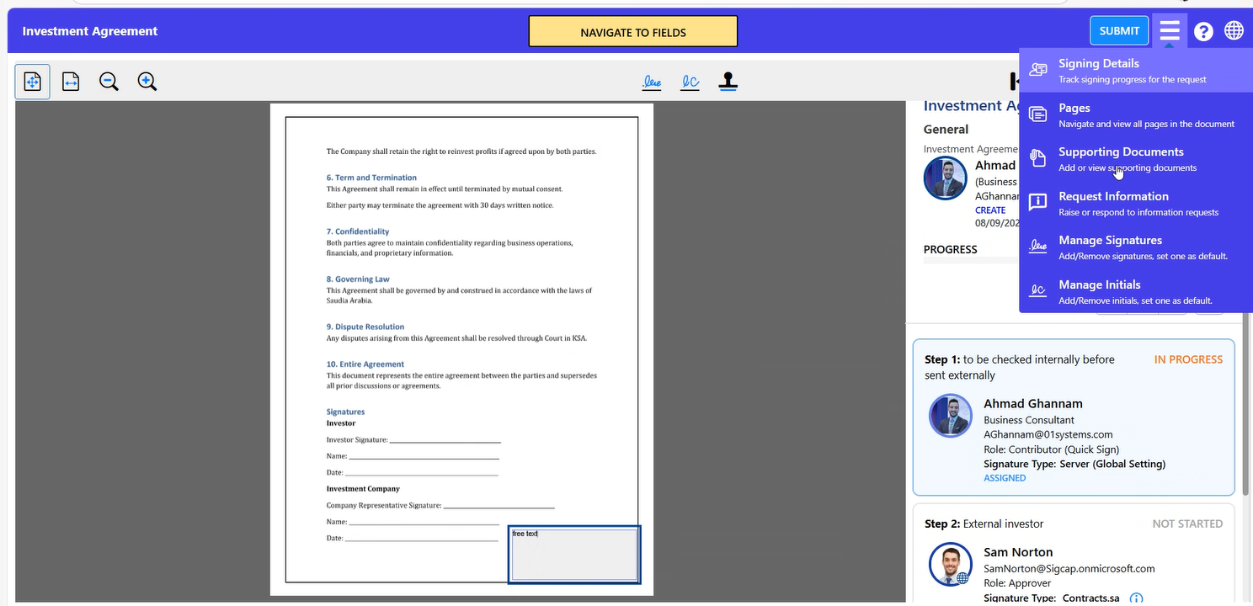
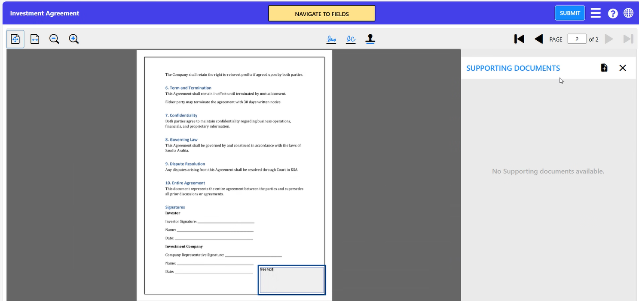
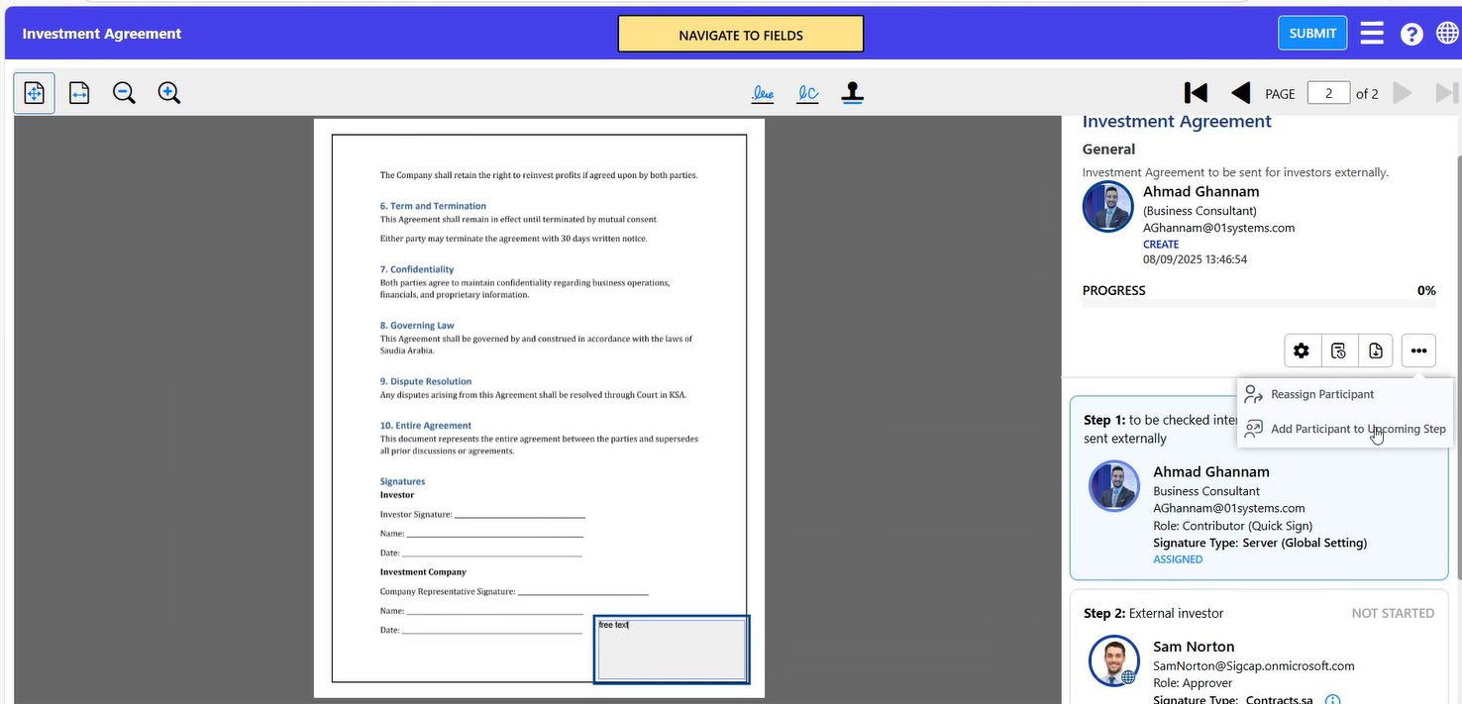
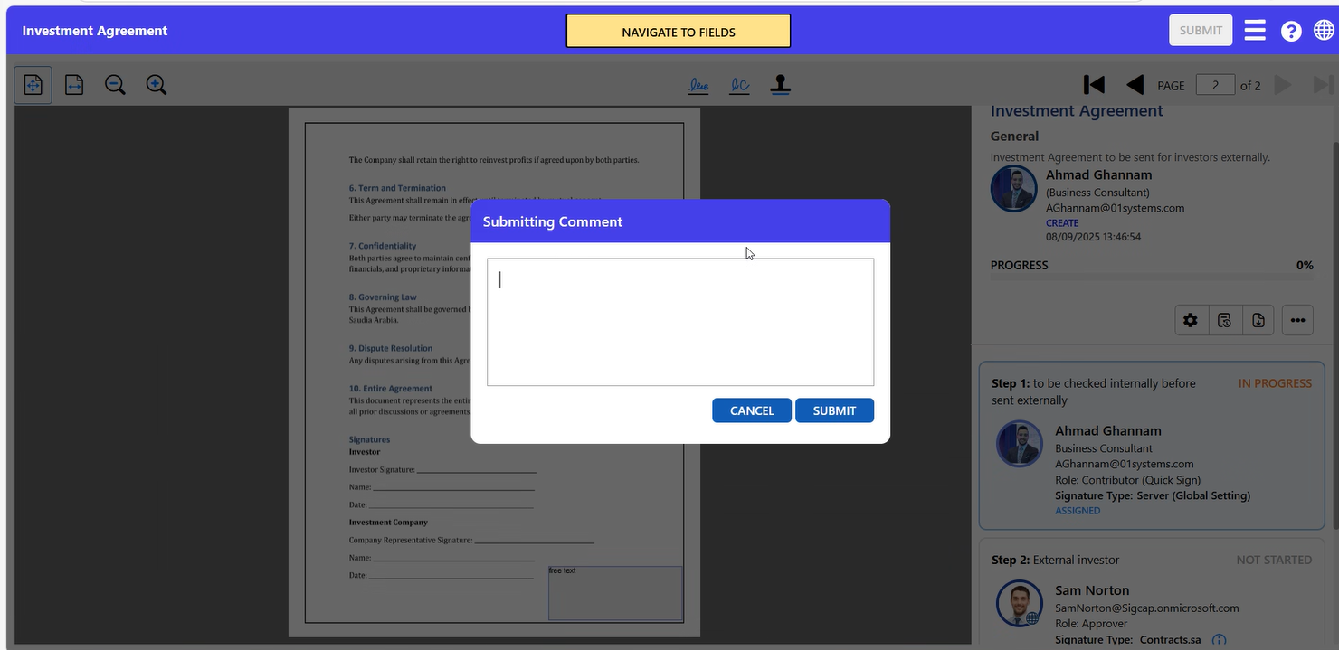
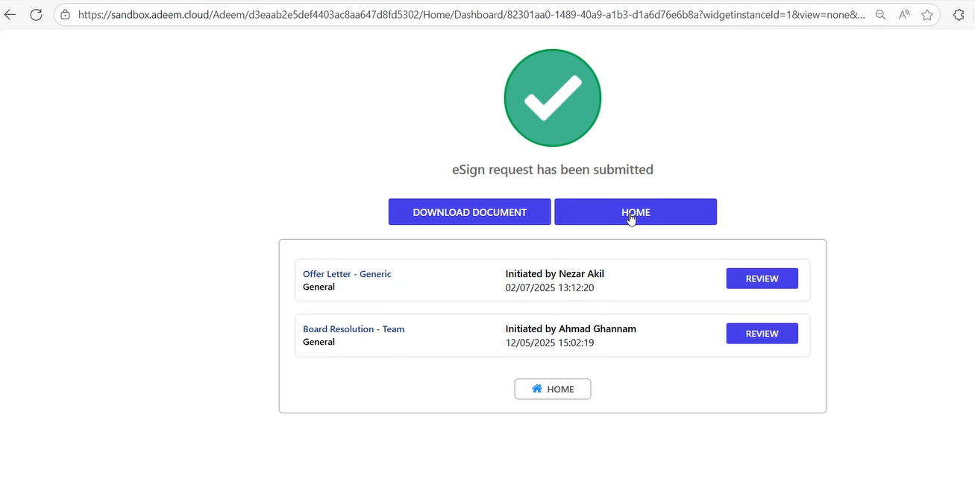
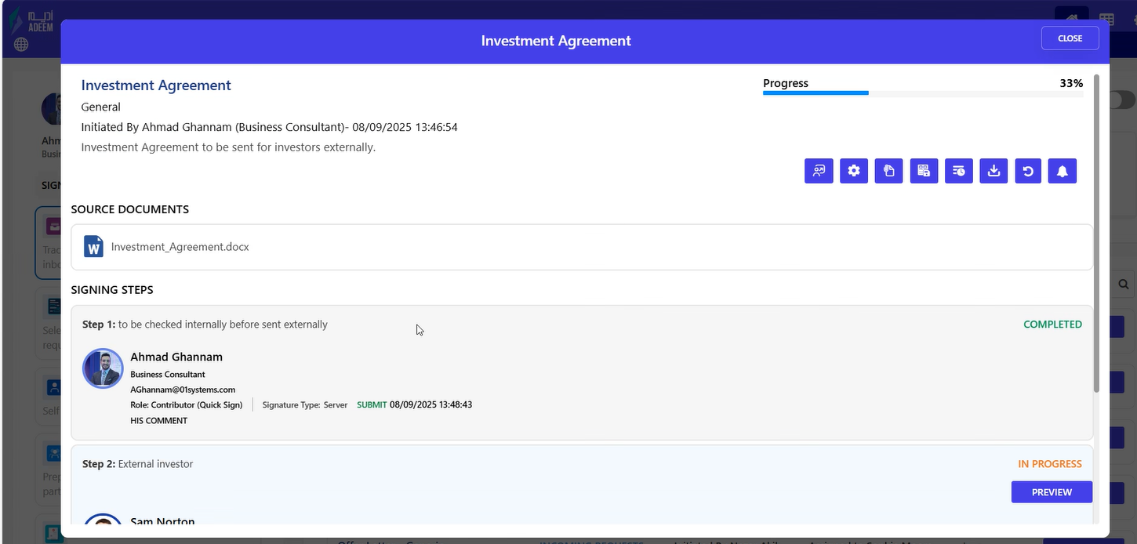
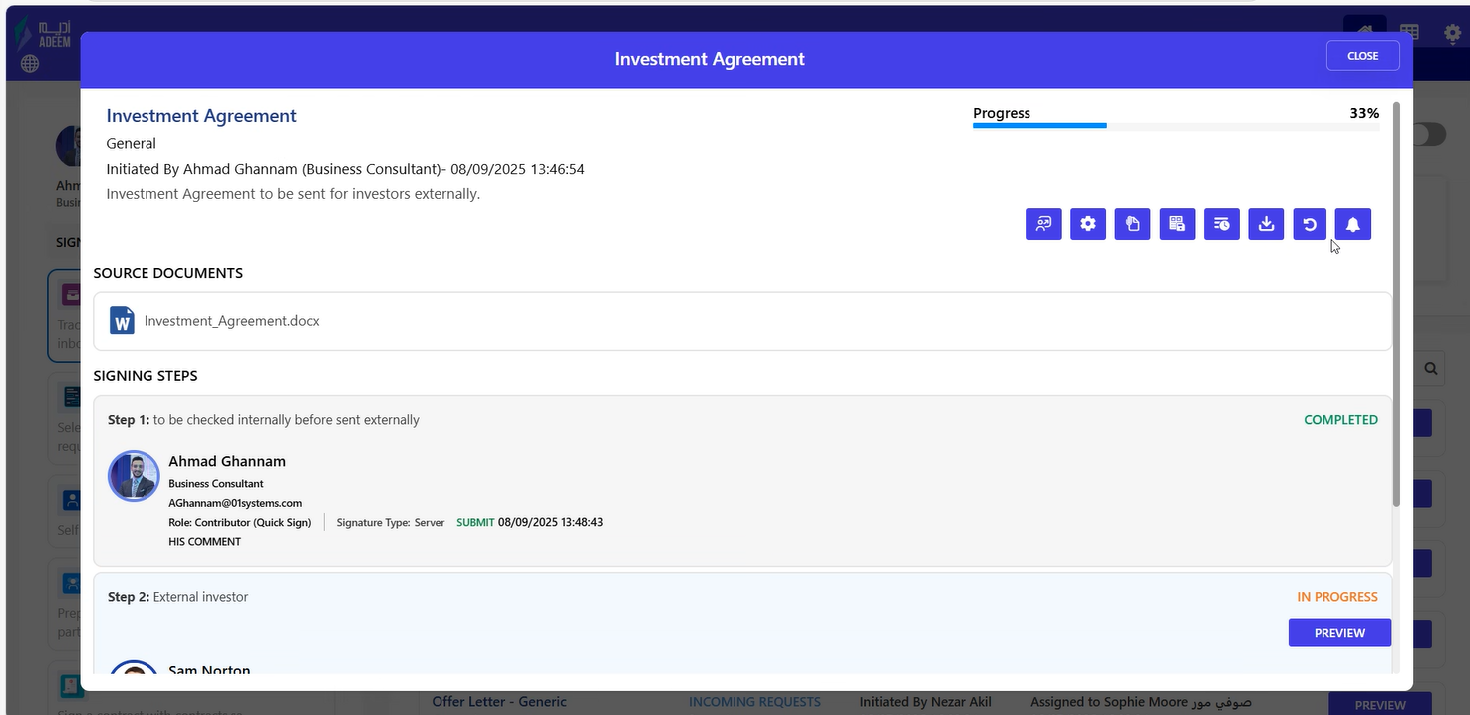
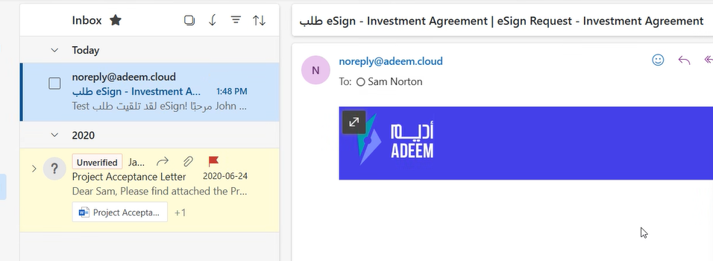
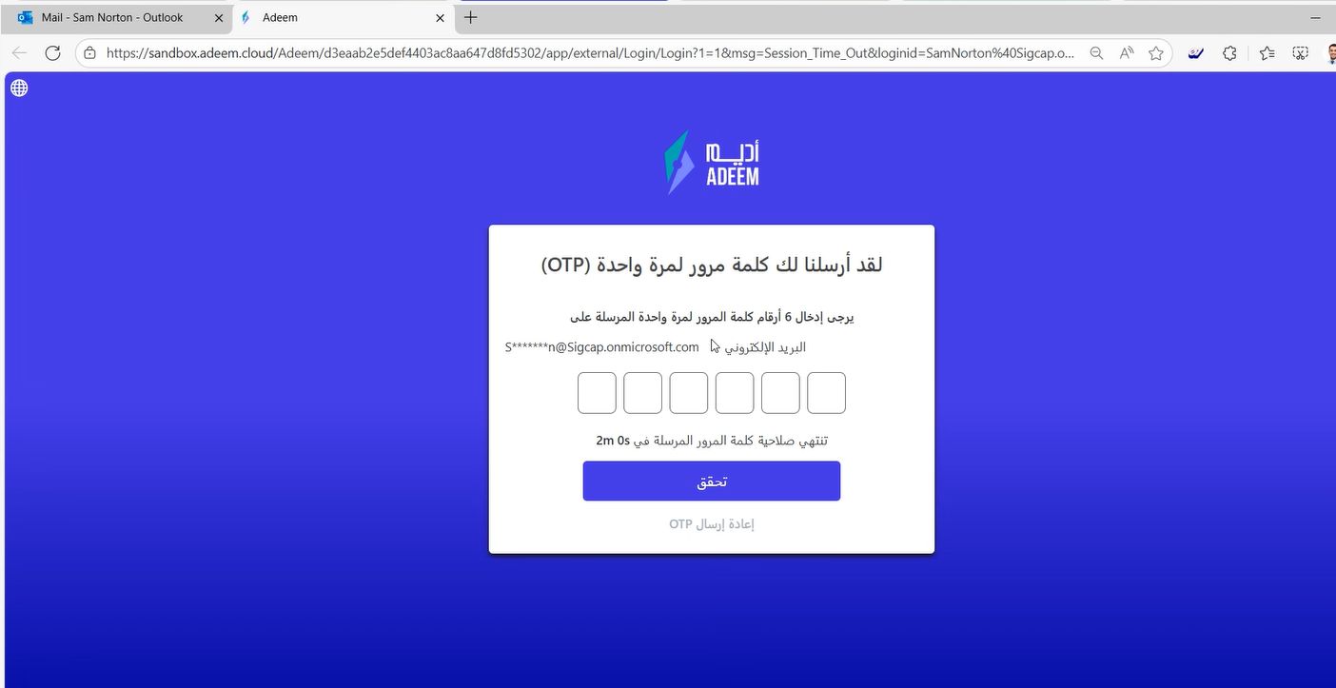
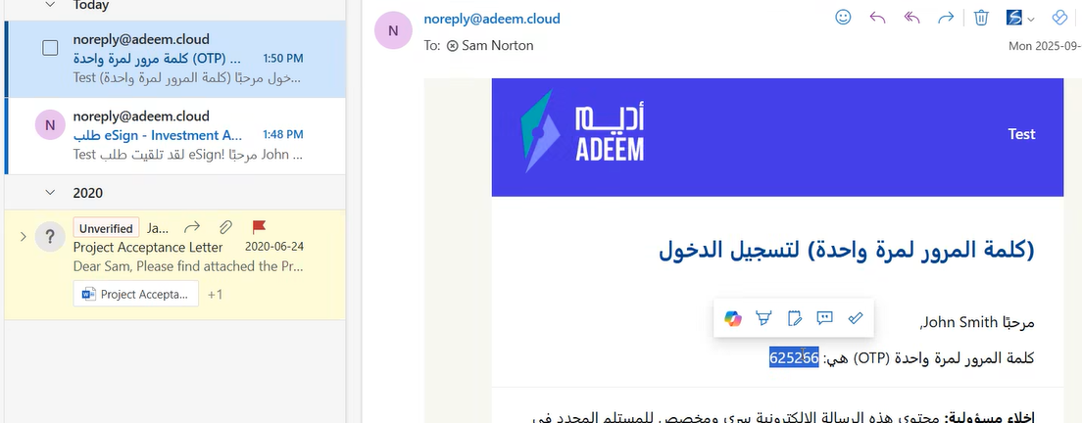
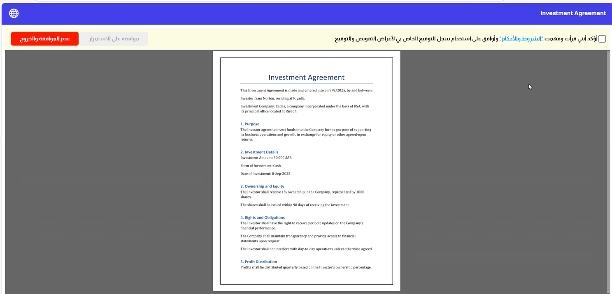
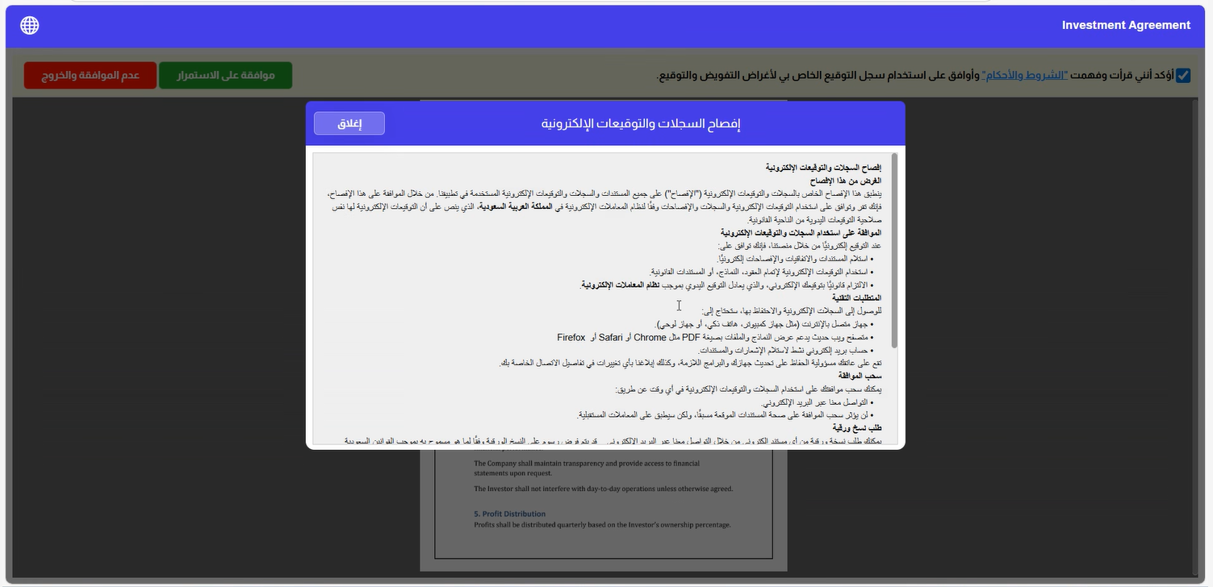
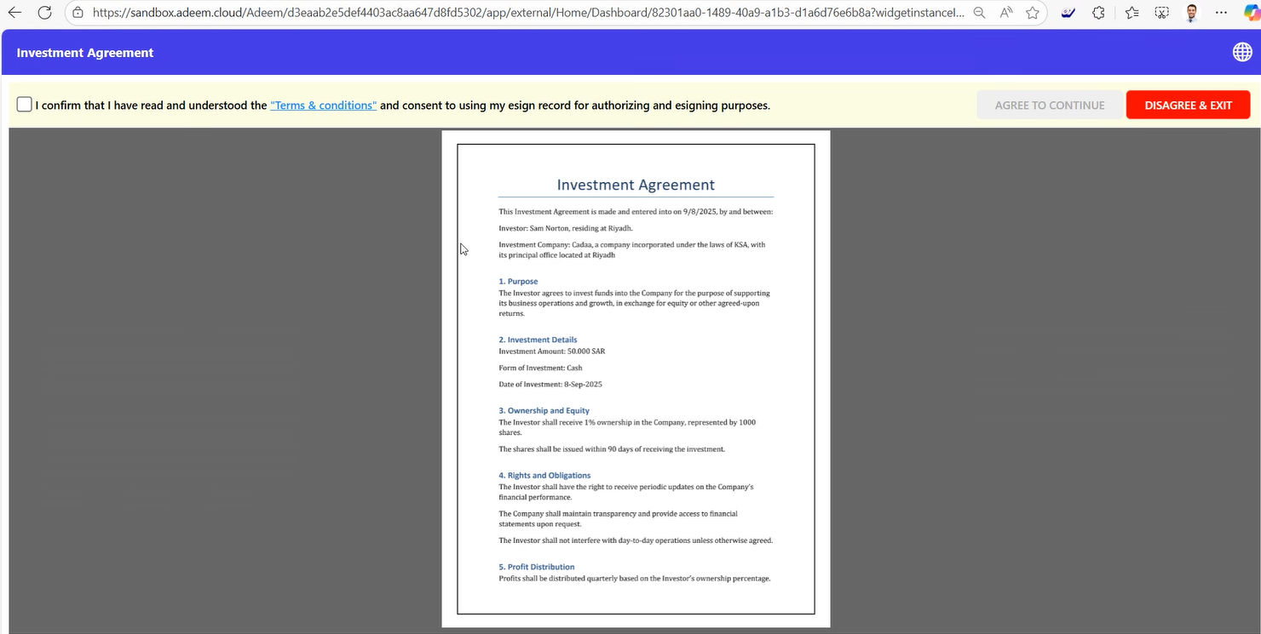
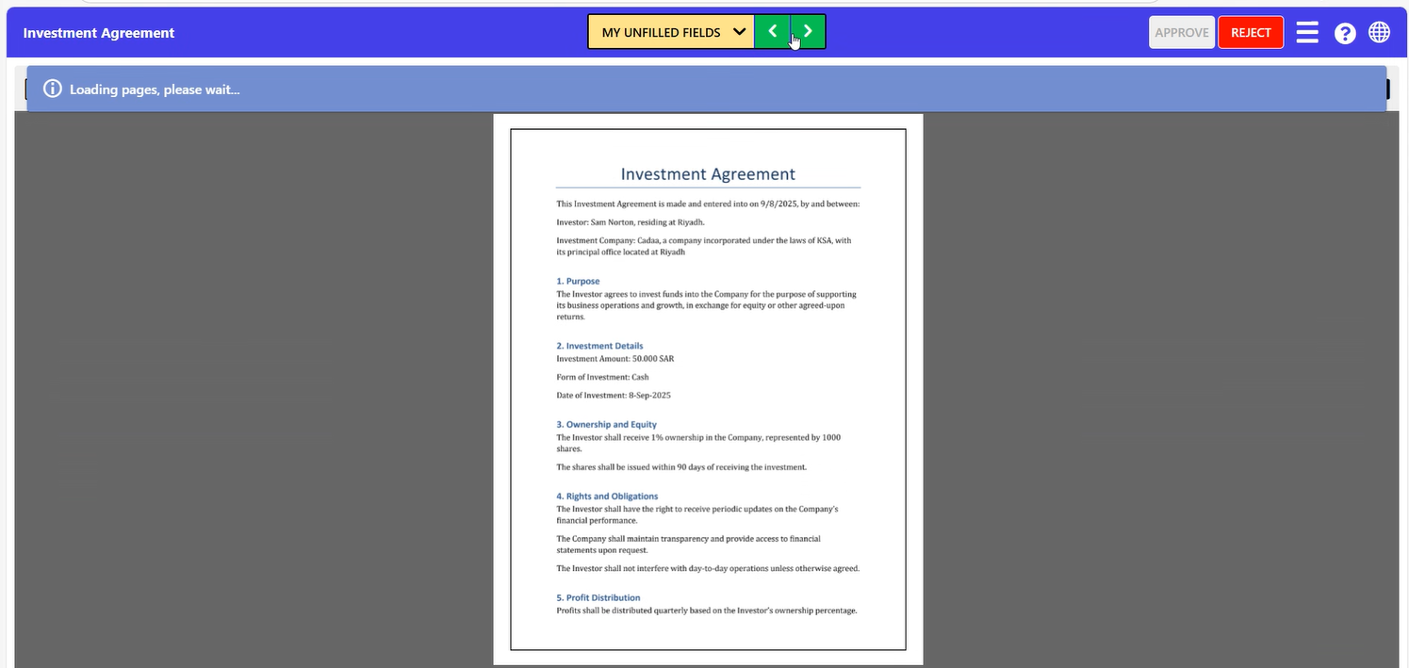
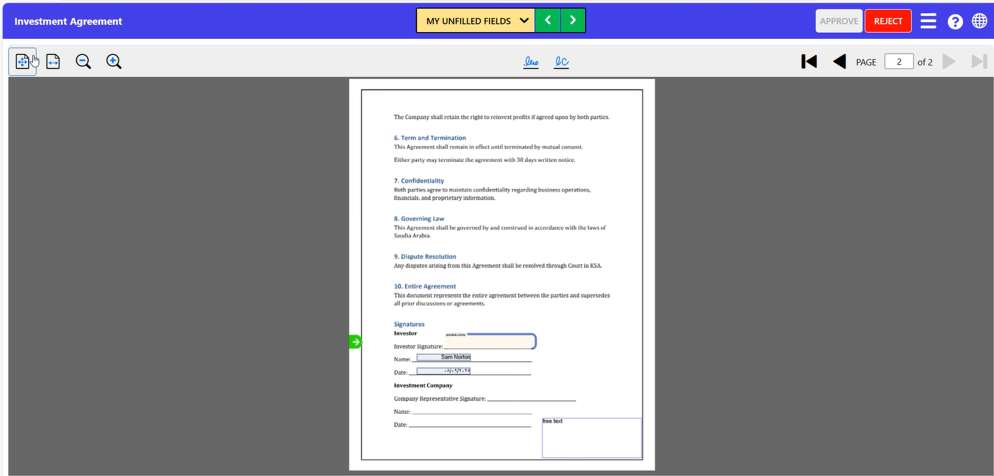

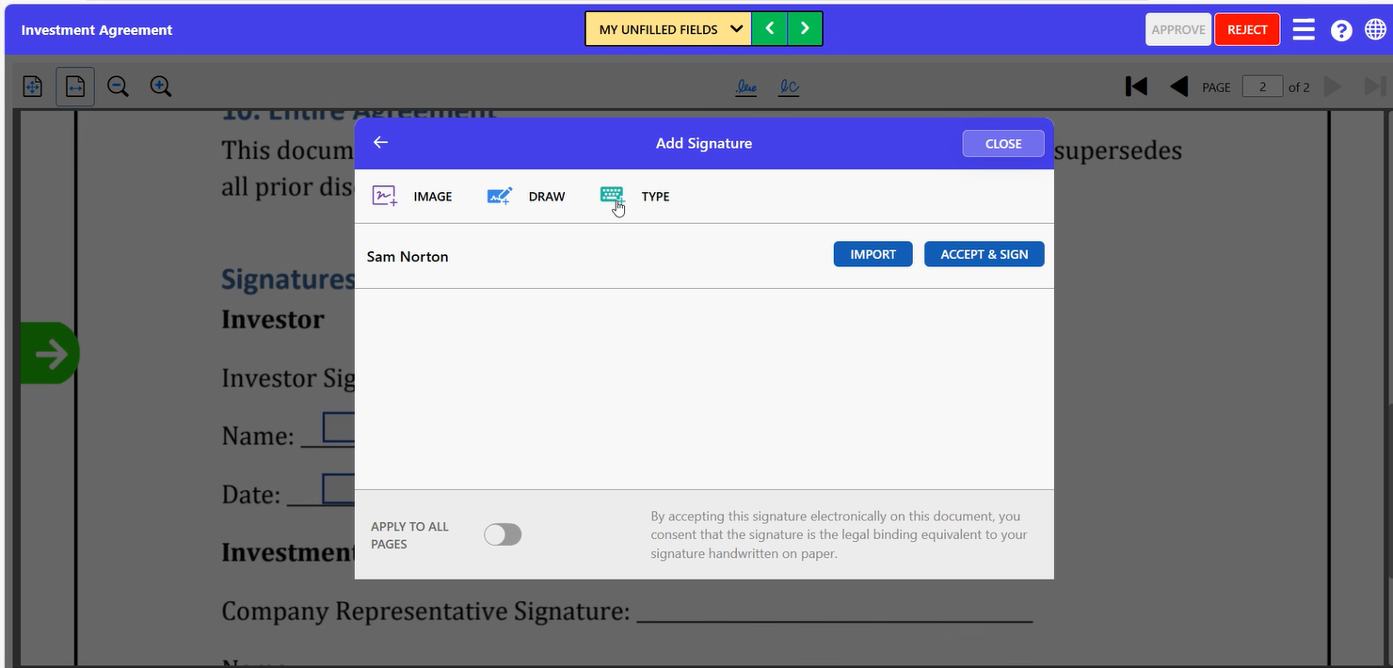
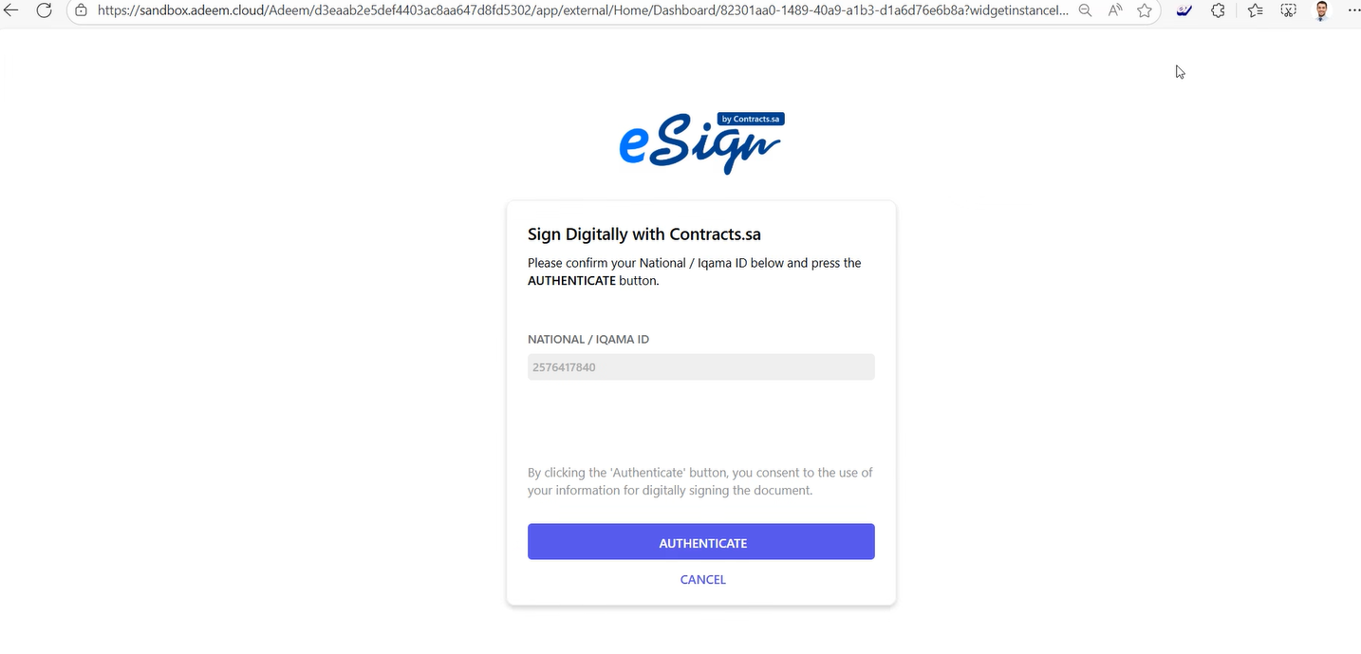
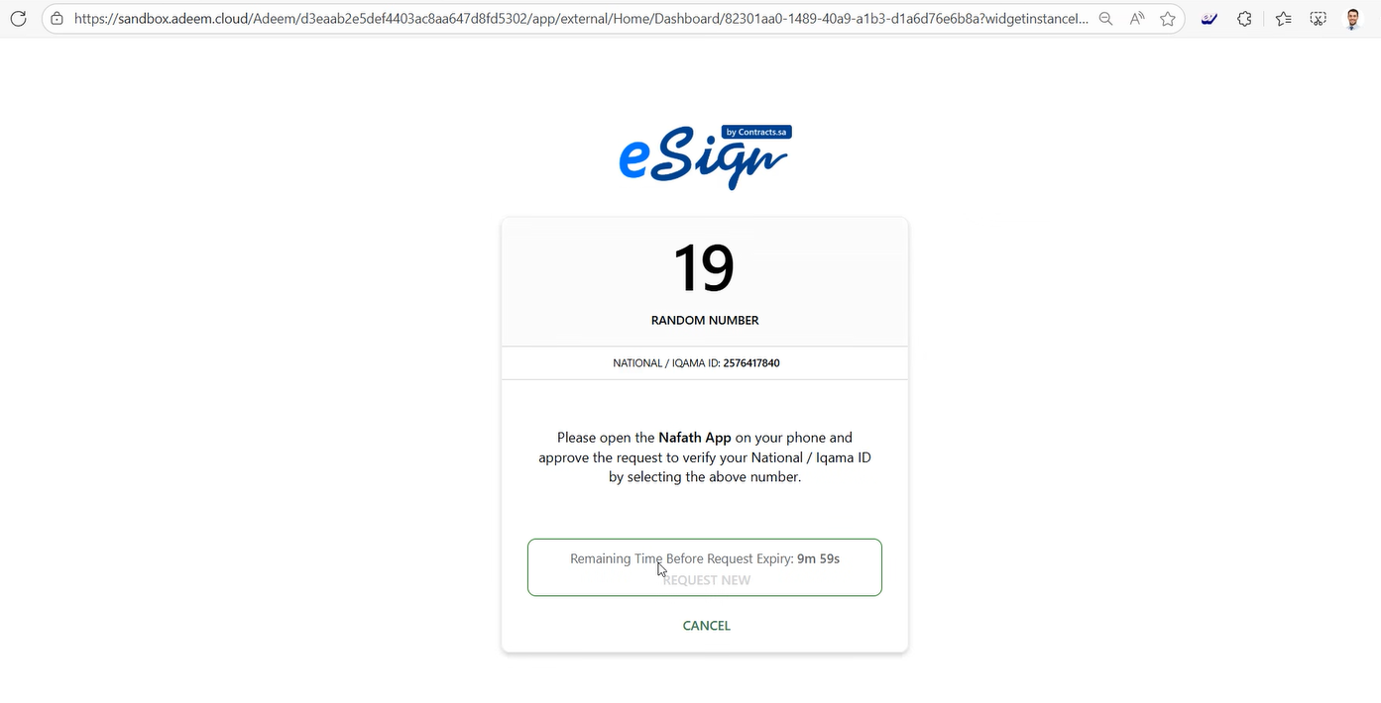
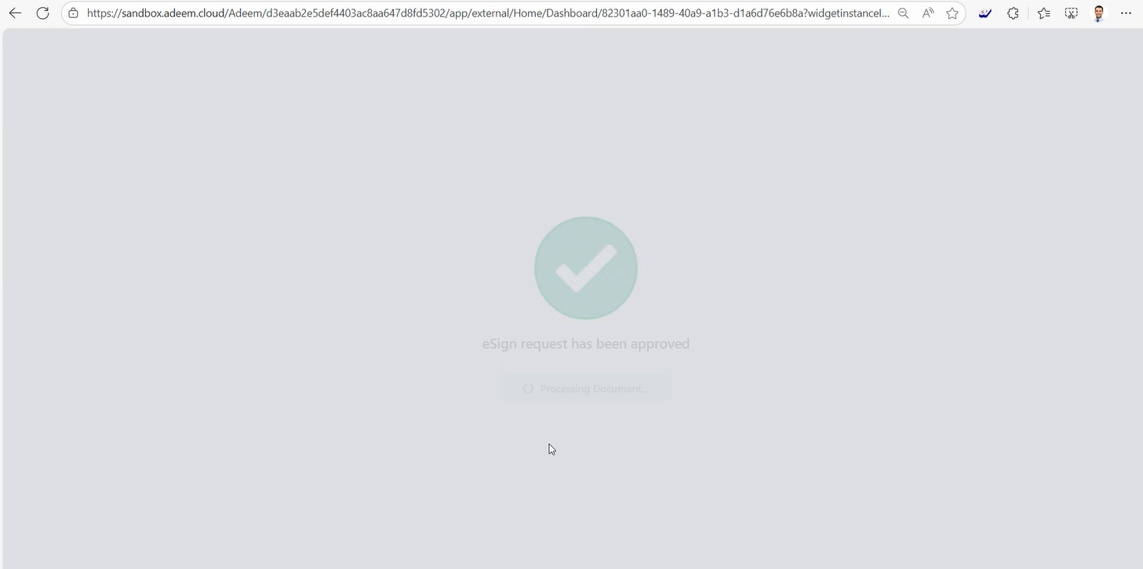
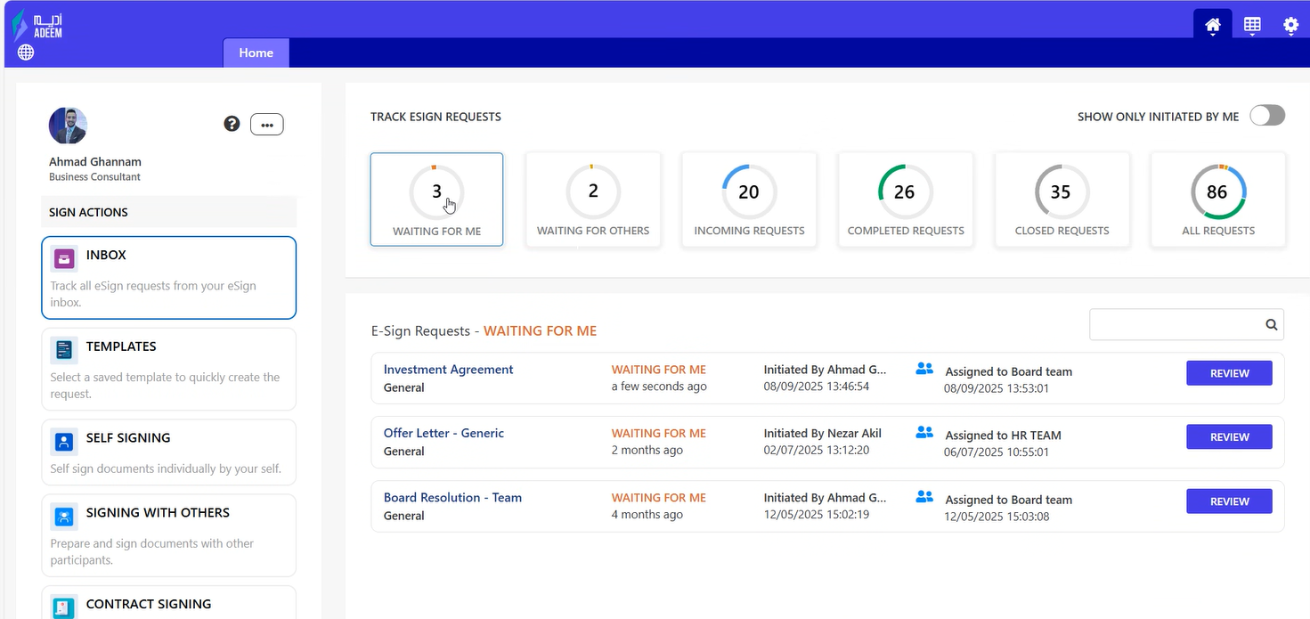
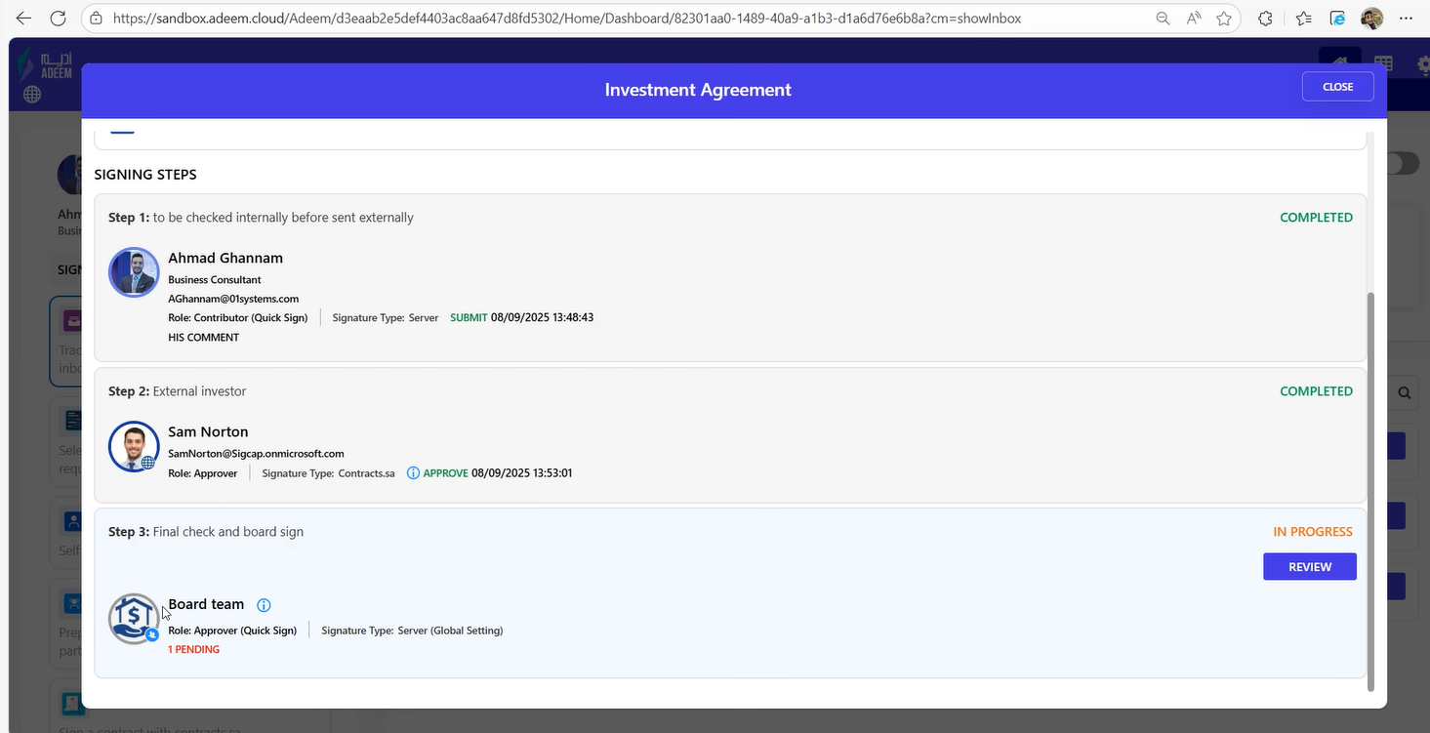
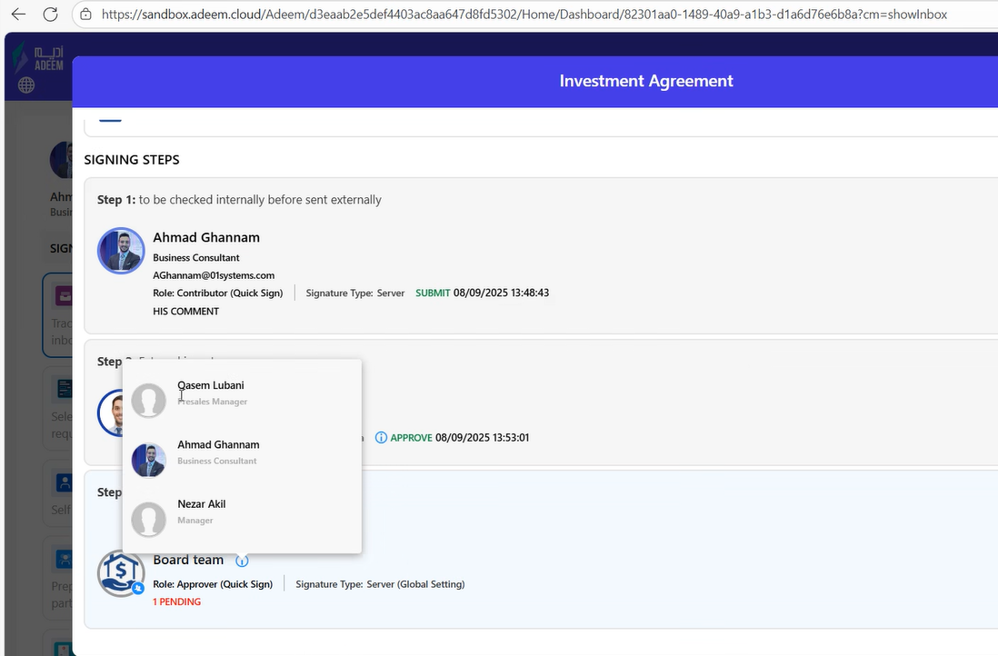
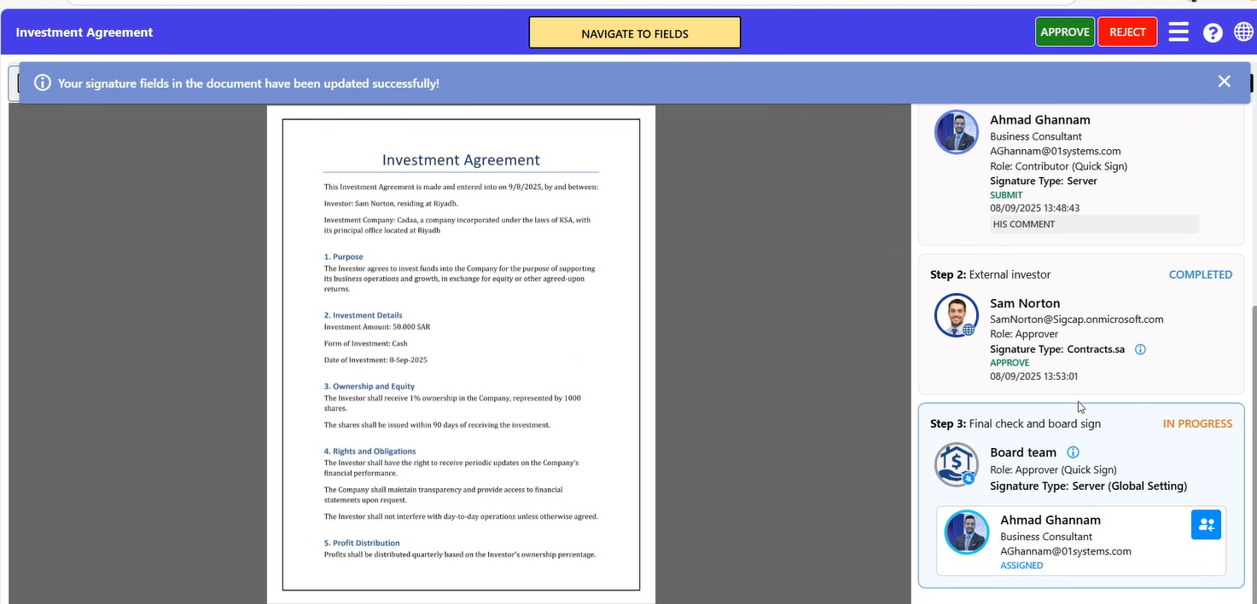
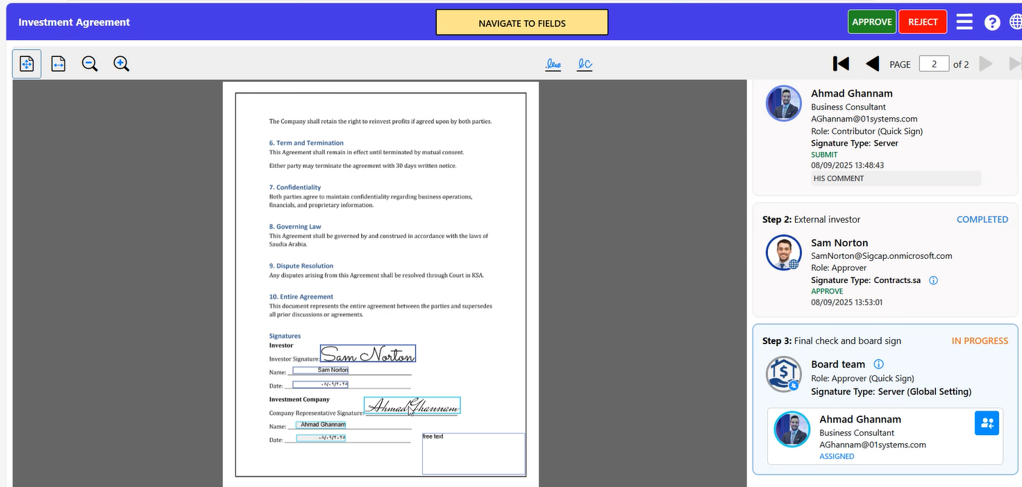
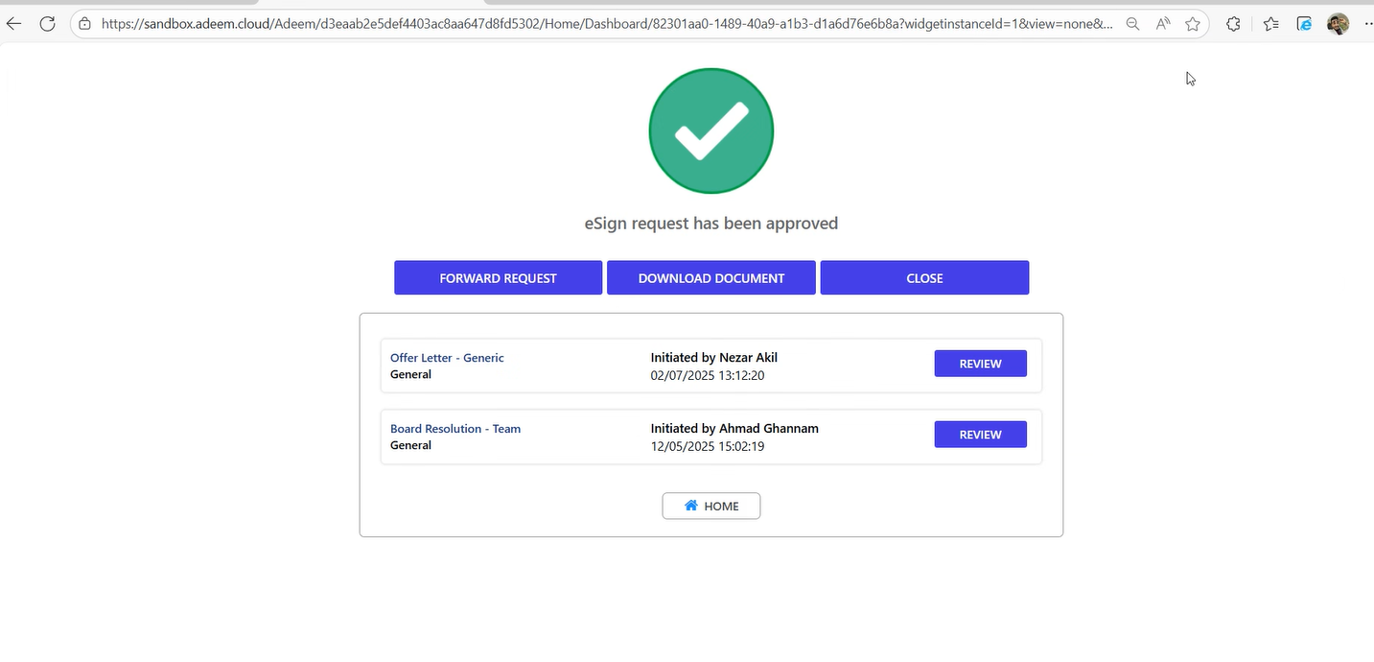
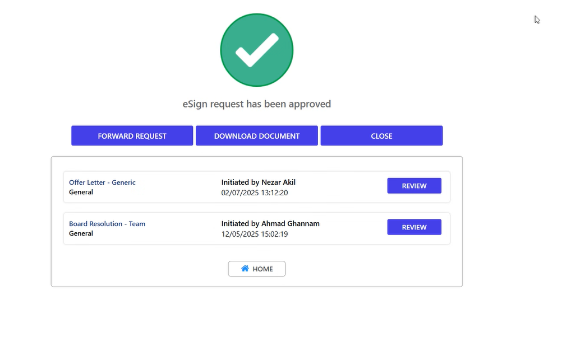
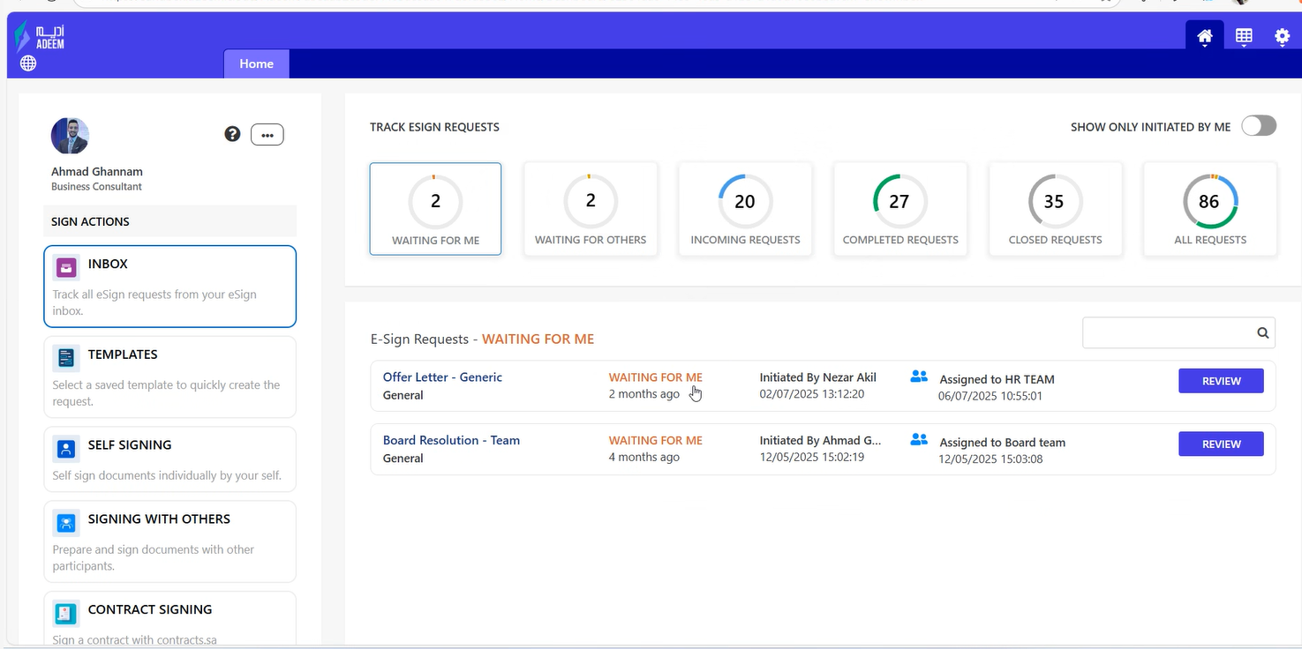
Signed document in email is the last step. Also integrate with MS 365.

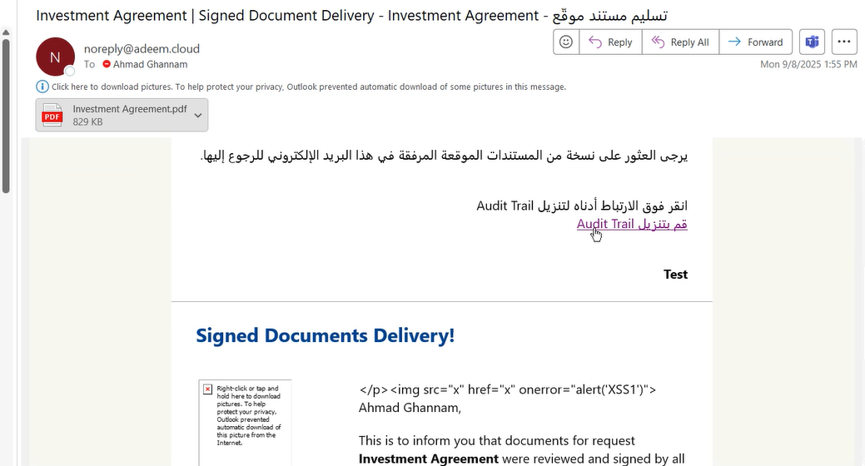
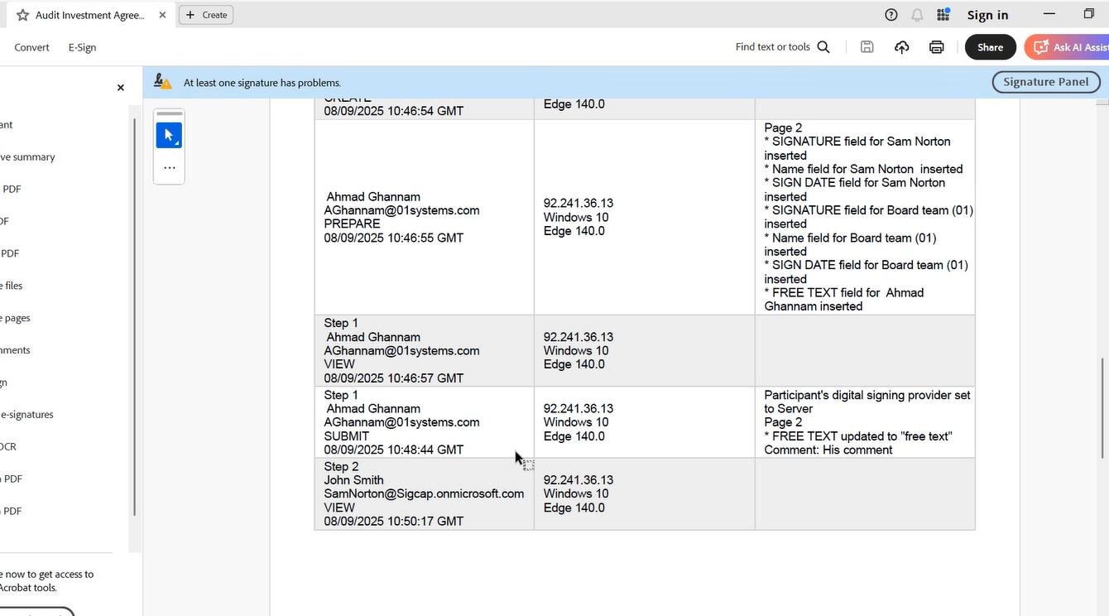

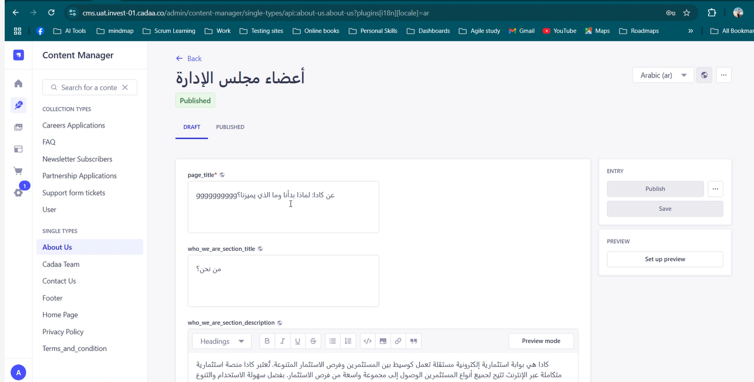
CMS for the e-Sign product.

